Bridgelea Curriculum Rainbow: Understanding People: To support children to understand themselves and understand others.
 | Elklan | Thinking School | Nurture Award | Rights Respecting | Nurture Award
 | 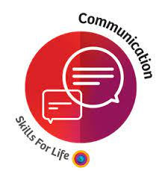 | 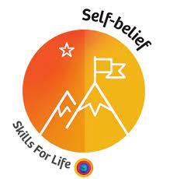 | 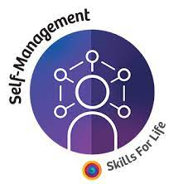 | 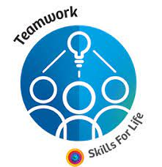 | 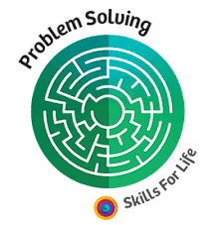
Manchester  Skills For Life | Communication is  being connected to others. It means the transfer of information from one person to another. It can be verbal, non verbal, written or even visual. | Self-Belief is about having a positive outlook, the drive or inspiration to have a go and the resilience to recover from setbacks whilst seeing mistakes as learning opportunities. | Self-Management being prepared and being ready. It means being organised, being accountable for your own actions. It's using your head and your initiative to take action without being told what to do. | Teamwork is being together and working towards a shared goal. It means that you can recognise each others' skills and strengths to help the team to achieve their goal in the most effective way. | Problem Solving is the process of working through details and ideas with the aim of finding a solution. The ultimate goal of problem solving is to overcome obstacles to find a solution that resolves an issue.
Skill Builder Definition | Listening  Speaking  The receiving, retaining and processing of  information or ideas.  - Verbal/non-verbal communication  - Visual communication through displaying their ideas  - Following instructions  - Giving and receiving feedback Active listening | Aiming High  The ability to set clear, tangible goals and  devise a robust route to achieving them.  - Self-reflection  - Practising positive self-talk | Staying Positive  The ability to use tactics and strategies to  overcome setbacks and achieve goals.  - Keeping to task and time  - Finishing the tasks given | Teamwork  Working cooperatively with others towards achieving a shared goal.  - Working with others on a shared task  - Trusting your partner  - Demonstrating leadership Involving and including others | Problem Solving  The ability to find a solution to a complex  situation or challenge.  - Creative thinking  - Practising problem solving process  - Exploring consequences and making decisions

 | Autumn 1 | Autumn 2 | Spring 1 | Spring 2 | Summer 1 | Summer 2
Cross Curricular  Skill Focus  All Mile Posts  Repeats Annually | Introduction & Refresh  Skills for Life | Listening (SB)  Communication  (S4L) | Aiming High (SB)  Self-Management  (S4L) | Staying Positive (SB)  Self-Belief  (S4L) | Problem Solving (SB)  Problem Solving (S4L) | Teamwork (SB)  Teamwork (S4L)
 |  | 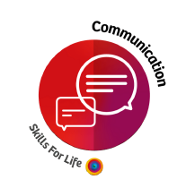 | 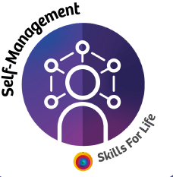 | 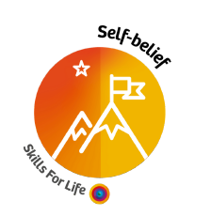 | 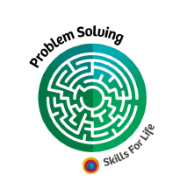 | 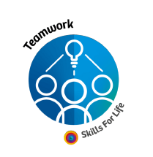

Communication is
Being connected to others. It means the transfer of information from one person to another. It can be verbal, non verbal, written or even visual.
Skills Builder Speaking
This skill is all about how to communicate effectively with others, being mindful of whether they are talking to customers, colleagues or other stakeholders and in different settings.Initially, this skill focuses on being able to speak clearly - first with well known individuals and small groups and then with those who are not known.The next stage is about being an effective speaker by making points logically, by thinking about what listeners already know and using appropriate language, tone and gesture
Step | Learner Descriptor | Teacher Explanation | Progression
Step 0 | I speak clearly to someone I know | Learners speak clearly to someone they know | - I understand what speaking is  - I respond to simple questions and prompts  - I speak clearly so another person understands me
Step 1 | I speak clearly to small groups of people I know | Learners speak clearly to small groups of people they know | - I understand how to engage more than one person  - I speak in front of others  - I speak clearly so more than one person understands me
Step 2 | I speak clearly to individuals and small groups I do not know | Learners speak clearly to individuals and small groups they do not know | - I understand what is different about talking to people  - I don’t know I speak clearly to individuals  - I do not know I speak clearly to small groups I do not know
Step 3 | I speak effectively by making points in a logical order | Learners speak effectively by making points in a logical order | - I understand what it means to say things in a logical order  - I understand why putting things in a logical order is important when speaking  - I use different approaches to putting things in a logical order
Step 4 | I speak effectively by thinking about what my listeners already know | Learners speak effectively by thinking about what their listeners already know | - I understand why it is important to know what my listeners already know  - I know how to build on what my listeners already know  - I explain new concepts that listeners are able to follow
Step 5 | I speak effectively by using appropriate language | Learners speak effectively by using appropriate language | - I understand why language changes in different settings  - I explain the difference between formal, informal and technical language  - I judge what language is appropriate in different settings
Step 6 | I speak effectively by using appropriate tone, expression and gesture | Learners speak effectively by using appropriate tone, expression and gesture | - I know what tone is and what is appropriate in different settings  - I know what expression is and what is appropriate in different settings  - I know what gesture is and what is appropriate in different settings

Communication is
Being connected to others. It means the transfer of information from one person to another. It can be verbal, non verbal, written or even visual.
Skills Builder Listening

Step | Learner Descriptor | Teacher Explanation | Progression
Step 0 | I can listen to others for a short time. |  | - I know what it means to listen  - I know what interrupting is, and why to avoid it  - I know some ways to avoid interrupting
Step 1 | I listen to others and can remember short instructions |  | - I know why recalling instructions matters  - I concentrate when listening to instructions  - I store and recall simple instructions
Step 2 | I listen to others and can ask questions if I don’t understand |  | - I know why it is important to understand what I have heard  - I think about whether I understand what I have heard  - I ask questions of what I have not understood
Step 3 | I listen to others and can tell someone else what it was about |  | - I listen effectively and stay focussed  - I retain and process information I have heard  - I recall and explain information to others
Step 4 | I can explain that there are different purposes to speech and how to identify them. |  | - I know the key reasons why people communicate  - I know why it is important to know why someone is communicating  - I can identify why someone is communicating with me
Step 5 | I listen to others and record important information as I do |  | - I can sustain concentration when listening over a longer period  - I identify key words and information from extended talks  - I record information in a way that makes it accessible again in the future
Step 6 | I show I am listening by how I use eye contact and body language |  | - I actively listen for a sustained period  - I maintain an appropriate level of eye contact with a speaker  - I show that I am listening through my body language

Self-Belief is about having a positive outlook, the drive or inspiration to have a go and the resilience to recover from setbacks whilst seeing mistakes as learning opportunities.

Staying Positive: The ability to use tactics and strategies to overcome setbacks and achieve goals. It starts with learners being able to recognise simple emotions and suggest why people feel these. The next stage is about developing learners’ capacity to keep trying when things go wrong. Once learners have mastered this, they move on to being able to identify the positives in difficult situations, and sharing this with others.
Step | Learner Descriptor | Teacher Explanation | Progression
Step 0 | I can say why people might be happy or sad. | Learners can articulate basic emotions and understand that other people will have changing emotions too. | - I am aware that people have feelings.  - I can name simple emotions.  - I know that emotions can change.
Step 1 | I can say when things go wrong and why people can get angry or upset. | Learners can see that people might get angry or upset when things go wrong and see how this links to their own experiences. | - I know that emotions can change because different things have happened.  - I can give examples of when 'something goes wrong'.  - I can explain how I feel when something goes wrong.
Step 2 | I can explain why giving up when something goes wrong does not help. | Learners can articulate why it is important to manage negative emotions when they face setbacks. They might not always be able to put this into practice. | - I can identify times when people might want to give up.  - I can explain the downside of giving up.  - I can explain how choosing to keep going might be a better choice.
Step 3 | I try to stay calm when something goes wrong. | Learners can respond to setbacks calmly. | - I can explain what calmness looks like.  - I can describe strategies to stay calm.  - I can apply strategies to stay calm when something goes wrong.
Step 4 | I keep trying when something goes wrong, and think about what happened. | Learners can be seen to respond positively to setbacks but also try to understand why the problem occurred and overcome that. | - I can identify the cause of the problem.  - I can identify positive strategies for when things go wrong.  - I can apply positive strategies to keep trying when things go wrong.
Step 5 | I keep trying when something goes wrong and help cheer other people up. | Learners continue to make an effort, even when they face setbacks, and can also cheer up their peers. | - I can explain how my actions can influence how others feel and act.  - I can describe a range of strategies to cheer up my peers.  - I can apply a range of strategies to cheer up my peers.
Step 6 | I keep trying and encourage others to keep trying, even when things are difficult. | Learners keep trying and are effective in encouraging others to maintain their level of effort in the face of setbacks. | - I can define the term 'motivate'.  - I can list a range of strategies to motivate my peers to keep trying.  - I can apply strategies to motivate my peers to keep trying.

Self-Management being prepared and being ready. It means being organised, being accountable for your own actions. It's using your head and your initiative to take action without being told what to do.
Aiming High: The ability to set clear, tangible goals and devise a robust route to achieving them. The first few steps are about effort: learners knowing why it is important to make an effort and what that might look like for them. In the next stage, learners move into goal planning: being able to set their goals and break down what and how they will achieve them.
 | Step |  | Learner Descriptor |  | Teacher Explanation |  | Progression
 | Step 0 |  | I can say when I find something difficult. |  | Learners will need to identify when something they are doing is difficult and articulate this to an adult. |  | - I am able to try new things.  - I can finish an activity I have started.  - I know that some activities can be more difficult than others.
 | Step 1 |  | I can tell someone what 'trying my best' means. |  | Learners can explain what ‘trying my best’ looks like in the context of their own work. |  | - I can say how hard I tried in a task.  - I can give an example of 'trying my best'.  - I can say what 'trying my best' looks like in different situations.
 | Step 2 |  | I can explain why it is important to try my best if I’m going to get better. |  | Learners show pride in their higher achievements and can articulate how it links to effort. |  | - I can give examples of when I might find something difficult.  - I can give a definition of 'difficult'.  - I can explain how something difficult will improve my understanding of something.
 | Step 3 |  | I can try my best and feel proud when I do. |  | Learners are aware of when they are working at their best, and find this a rewarding experience that they can take pride in. |  | - I can show how I am trying my best in different contexts.  - I can demonstrate my sense of achievement when I have tried my best.  - I can share what I have accomplished with others.
 | Step 4 |  | I look for chances to do something that I might find difficult and ask an adult to set me extra challenges. |  | Learners can seek out opportunities to give themselves extra challenges to increase their achievements. Teachers will provide learners with an achievable challenge. |  | - I can identify something I might find difficult, but 'do-able'.  - I look for chances to do something I might find difficult.  - I ask adults to set me extra challenges.
 | Step 5 |  | I can choose goals with some help from my teacher or another adult. |  | Learners can set a simple goal that is appropriate and achievable, with the support of a teacher or another adult. |  | - I can identify a 'simple goal'.  - I can explain what 'achievable' means.  - I can choose achievable goals for myself with help.
 | Step 6 |  | I can set my own goal that gives me a chance to try something I might find difficult. |  | Learners are able to approximately gauge what a stretching goal looks like and define that for themselves. |  | - I can identify challenges that I could set as a goal.  - I can assess which challenge will be the most difficult.  - I can use the information I have gathered to set my own goal.
Teamwork is being together and working towards a shared goal. It means that you can recognise each others' skills and strengths to help the team to achieve their goal in the most effective way.

Teamwork: Working cooperatively with others towards achieving a shared goal. The initial steps are about understanding why we work in teams before moving to the next stage which explores how learners can become effective team members. The next stage is all about being a supportive and inclusive team member, focused on how learners can ensure everyone’s ideas are valued.
 |  | Learner Descriptor |  | Teacher Explanation |  | Progression
Step 0 |  | I am happy to take turns with other children. |  | Learners are able and willing to take turns with their peers. |  | - I understand why working with others can be helpful  - I know what working positively looks like  - I recognise when it is difficult to work positively
Step 1 |  | I can work with other children to do something together. |  | Learners are able to make a contribution towards a bigger task as part of a group. |  | - I define what behaviour is with examples  - I know how behaviour might vary  - I identify the appropriate behaviour for different situations
Step 2 |  | I can explain why teams are sometimes better than working by myself. |  | Learners are able to articulate why teamwork can be more effective than individual work in some situations. |  | - I understand why being on time matters  - I can define reliability and why it matters  - I identify how to get better at being reliable
Step 3 |  | I help with different jobs in my team and take responsibility for finishing my job. |  | Learners can take on different jobs in their team to complete the team task. |  | - I can define what responsibility means  - I identify ways to take responsibility  - I understand when taking responsibility works well
Step 4 |  | I can get on well with my team and find ways to resolve a disagreement. |  | Learners are able to address disagreements and disputes in an effective way, and generally work well with others. |  | - I understand what it means to support others  - I explain why supporting others is important and helpful  - I know how to identify if I can support others
Step 5 |  | When I finish my task, I can help others complete their tasks on time too. |  | Learners can think beyond their own part of a task and actively try to support other team members to complete their jobs. |  | - I define and explain what diversity means  - I define and explain what equality means  - I define and explain what inclusivity means
Step 6 |  | I help my team make decisions and I make my own suggestions. |  | Learners can contribute to the decision-making process and are willing to put forward their own ideas. |  | - I define and explain what group decision making is  - I recognise the benefits of contributing to group decision making  - I know how to contribute positively to group discussions

Problem Solving is the process of working through details and ideas with the aim of finding a solution. The ultimate goal of problem solving is to overcome obstacles to find a solution that resolves an issue.

Problem Solving: The ability to set clear, tangible goals and devise a robust route to achieving them.The initial stages are about learners being able to explain a simple problem they may have and recognise they may need help. Once learners are able to identify problems, they begin learning how to use strategies to solve simple problems.
Step | Learner Descriptor | Teacher Explanation | Progression
Step 0 | I can follow instructions to solve a problem. | Learners can follow adult instructions to solve a problem. | - I can follow simple visual instructions.  - I can follow instructions to solve a problem with help.  - I can explain how following instructions can help me to solve a problem.
Step 1 | I can ask for help when I need it. | Learners can identify when they require adult support in overcoming difficulties and will seek a suitable adult for help with this. | - I know when I need help.  - I know who I can ask for help.  - I can say what I need help with.
Step 2 | I can explain a simple problem that I might have and get someone to help me with it. | Learners can identify simple problems and ask for adult support to scaffold possible solutions. | - I can identify when I have a problem.  - I can communicate what the problem is.  - I can make a list of people I could ask for help, including my peers.
Step 3 | I can find extra information with help from others to help me solve a simple problem. | Learners can identify when they need extra information to solve a simple problem and can find that information with help from an adult or peers. | - I can identify what I already know about a problem.  - I can identify what I need to know about a problem.  - I can explain where I would go for extra information.
Step 4 | I can come up with different ways to solve a simple problem. | Learners appreciate that there are frequently different ways to solve a problem and can explain different options in a given situation. | - I can break down a problem into its causes and effects.  - I can look for more than one solution to a problem.  - I can list more than one solution to a problem.
Step 5 | I can use pros and cons to pick the best way of solving a simple problem. | Learners can articulate a problem and evaluate different potential solutions to choose the option they think will be most effective (with adult support). | - I can define 'pros' and 'cons'.  - I can identify the pros and cons of different solutions.  - I can apply pros and cons to an evaluation of solutions to make the best choice.
Step 6 | I can explain the difference between simple and complex problems. | Learners can identify complex problems (e.g. I can’t decide on a secondary school) and explain how these differ from simple problems (e.g. what I need to pack for holiday). They can explain why different approaches might be needed. | - I can define 'simple problem' and 'complex problem'.  - I can describe the difference between simple and complex problems.  - I can explain why different approaches might be needed to solve them.

