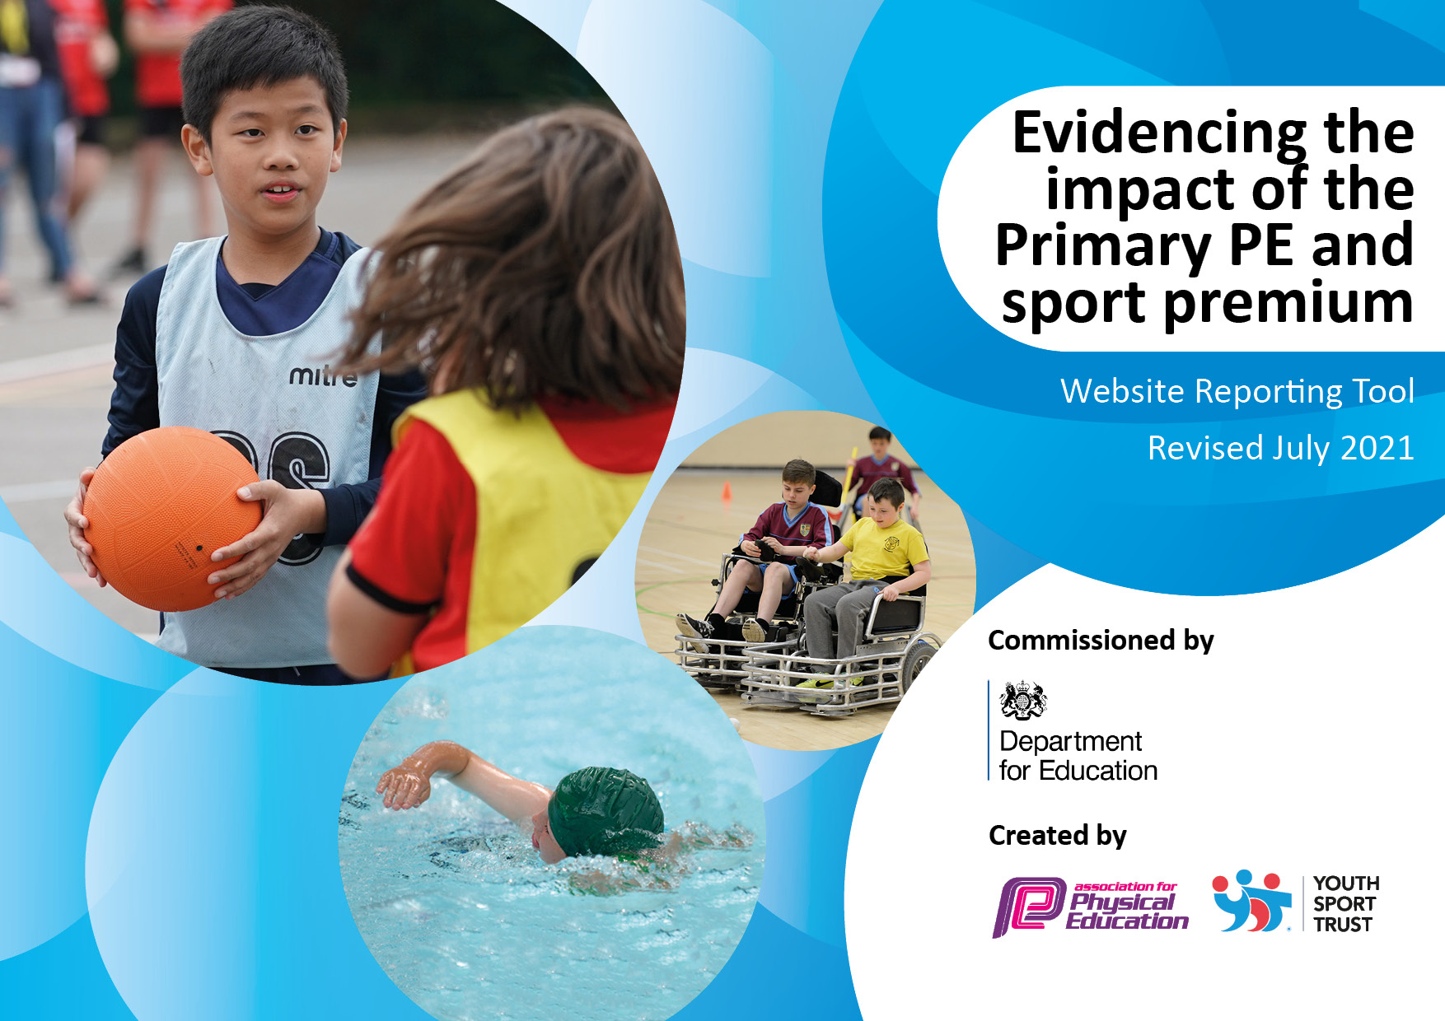
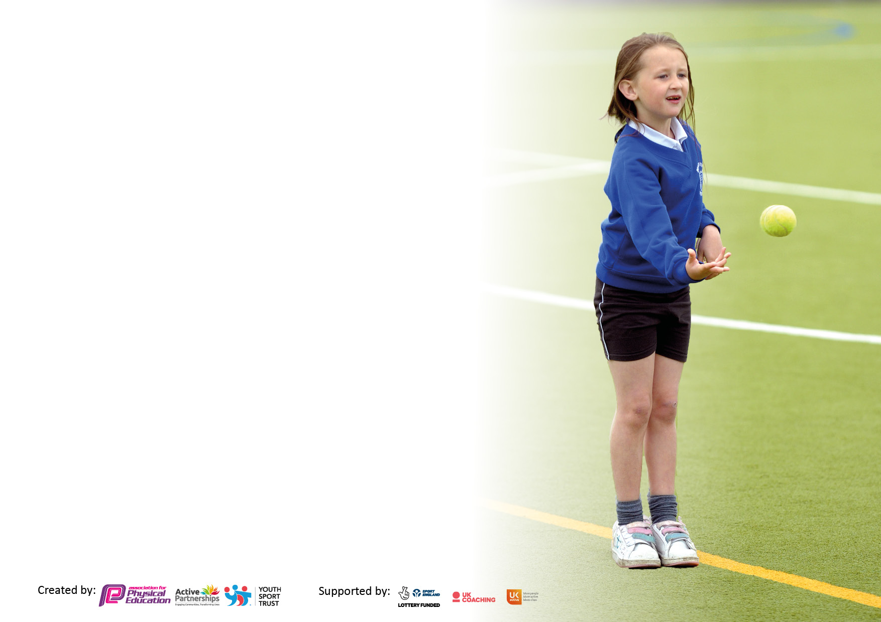

It is important that your grant is used effectively and based on school need. The Education Inspection Framework makes clear there will be a focus on ‘whether leaders and those responsible for governors all understand their respective roles and perform these in a way that enhances the effectiveness of the school’.

Under the Quality of Education Ofsted inspectors consider:
Intent - Curriculum design, coverage and appropriateness
Implementation - Curriculum delivery, Teaching (pedagogy) and Assessment
Impact - Attainment and progress

To assist schools with common transferable language this template has been developed to utilise the same three headings which should make your plans easily transferable between working documents.

Schools must use the funding to make additional and sustainable improvements to the quality of Physical Education, School Sport and Physical Activity (PESSPA) they offer. This means that you should use the Primary PE and sport premium to:

- Develop or add to the PESSPA activities that your school already offer
- Build capacity and capability within the school to ensure that improvements made now will benefit pupils joining the school in future years
- The Primary PE and sport premium should not be used to fund capital spend projects; the school’s budget should fund these.

Please visit gov.uk for the revised DfE guidance including the 5 key indicators across which schools should demonstrate an improvement.
This document will help you to review your provision and to report your spend.DfE encourages schools to use this template as an effective way of meeting the reporting requirements of the Primary PE and sport premium.

We recommend you start by reflecting on the impact of current provision and reviewing the previous spend.

Schools are required to publish details of how they spend this funding, including any under-spend from 2019/2020, as well as on the impact it has on pupils’ PE and sport participation and attainment. All funding must be spent by 31st July.

We recommend regularly updating the table and publishing it on your website throughout the year. This evidences your ongoing self-evaluation of how you are using the funding to secure maximum, sustainable impact. Final copy must be posted on your website by the end of the academic year and no later than the 31st July 2021.

Details with regard to funding
Please complete the table below.

Total amount allocated for 2022/23 | £ 16,760
Total amount of funding for 2022/23. To be spent and reported on by 31st July. | £ 20,270
Total amount allocated for 2023/24 | £ 16,760
Total amount carried over from 2022/23 | £ 1,835
Total amount of funding for 2023/24. To be spent and reported on by 31st July 2024. | £ 18,595
Swimming Data
Please report on your Swimming Data below.

At Bridgelea we use the premium to raise attainment in school swimming and water safety by funding top-up swimming sessions for those children that do not meet national curriculum requirements after they’ve completed core swimming lessons.
Meeting national curriculum requirements for swimming and water safety. Due to exceptional circumstances priority should be given to ensuring that pupils can perform safe self-rescue even if they do not fully meet the first two requirements of the NC programme of study
What percentage of your current Year 6 cohort swim competently, confidently and proficiently over a distance of at least 25 metres? N.B. Even though your pupils may swim in another year please report on their attainment on leaving primary school at the end of the summer term 2021. | 6%
What percentage of your current Year 6 cohort use a range of strokes effectively? | 1%
What percentage of your current Year 6 cohort perform safe self-rescue in different water-based situations? | 1%
Schools can choose to use the Primary PE and sport premium to provide additional provision for swimming but this must be for activity over and above the national curriculum requirements. Have you used it in this way? | Yes

Action Plan and Budget Tracking
Capture your intended annual spend against the 5 key indicators. Clarify the success criteria and evidence of impact that you intend to measure to evaluate for pupils today and for the future.

Academic Year: 2022/23 | Total fund allocated: £22,270 | Date Updated: July 2022 |  | Percentage of total allocation:  0%
Key indicator 1: The engagement of all pupils in regular physical activity – Chief Medical Officers guidelines recommend that primary school pupils undertake at least 30 minutes of physical activity a day in school
Intent | Implementation |  | Impact
Class teachers to lead/teach PE. |  | £NA | - CT’s to teach 1 x PE sessions per week. Swimming is a part of the PE offer and is repeated throughout KS2.  - There is an increasing range of sports and physical activities available throughout the curriculum. This has been informed by the School Council & Pupil Voice.  - Pupils have experiences of playing varied sports both challenging and supporting their complex needs.  - All pupils access PE lessons and PE activities and enrichment, regardless of SEND. The PE curriculum is adapted to meet the needs of Bridgelea pupils. | - This has worked well, PE has been taught throughout the school year.

Raising attainment in swimming to meet requirements of the national curriculum before the end of Key stage 2. | Two weekly swimming lessons to be shared equally between Withington and Longsight. | £6,722. | - All access swimming twice yearly.  - Swimming distances, badges and lengths are recorded by swimming coaches and awarded to children throughout the year.  - Children experience success in swimming and improve their awareness and ability to keep safe in and around water. This is supported by repeated access to swimming tuition.  - This contributes towards the pupils one hour of PE a week and recommended 30 minutes of physical activity a day.  - Many families are unable to access public swimming opportunities, this supports children to access swimming within their community.  - This supports children to develop a love of swimming and to develop a hobby or leisure activity that they can access in their community. | 33%  - Low percentage of national curriculum requirements for swimming.  - Limited external swimming by parents/carers. This reinforces the importance of these lessons in school to develop water safety.

Key indicator 2: The profile of PESSPA being raised across the school as a tool for whole school improvement |  |  |  | Percentage of total allocation: 10%
Intent | Implementation |  | Impact
School PE (Outdoor Adventurous Activities) enrichment activities. | Canoeing opportunities (Debdale) | £1,106 x 6 sessions | - Extremely well received by staff and pupils.  - This has supported access to OAA opportunities not available at home.  - Widened knowledge of more unusual sports.

Key indicator 3: Increased confidence, knowledge and skills of all staff in teaching PE and sport |  |  | Percentage of total allocation: 0%
Intent | Implementation |  | Impact
Providing staff with mentoring to teach sport and PE more effectively. | PE Coordinator to lead training for staff increasing confidence in teaching PE.  Additional support for ECTs | NA | - Session used to upskill CT’s. Informal drop ins used by staff to discuss PE curriculum and the teaching of PE at Bridgelea.  - Increased confidence and subject knowledge of class teachers supporting high quality PE teaching.

Key indicator 4: Broader experience of a range of sports and activities offered to all pupils |  |  | Percentage of total allocation: 25%
Intent | Implementation |  | Impact
To support children in Y5 to access a high quality outdoor learning opportunity to develop and build their learning through adventurous and challenging activities at Ghyll Head. | Introducing new sports or activities to encourage more pupils to take up sport.  Links to Manchester Skills 4 Life | £3,600 | - Increased pupil well-being.  - Development of a range of skills that children at Bridgelea struggle with including: SLCN, motor skills, coordination, special awareness, resilience.  - Nurture of positive relationships with staff and peers.  - Confidence in choosing equipment that is appropriate for an activity.  - Improved ability to complete activities in a set period of time and beginning to be able to offer an evaluation of personal performances and activities.  - Improved communication & teamwork skills
Providing staff with resources to teach sport and PE more effectively and embed physical activity/PE across the school. | Continue to develop the stock of PE Equipment to reflect the introduction of an adapted Bridgelea PE scheme. | £4,156 | - Purchasing gymnastic equipment.  - Re stock of lost equipment.

Academic Year: 2023/24 | Total fund allocated: £18,594 | Date Updated: July 2023 |  | Percentage of total allocation:  33.8%
Key indicator 1: The engagement of all pupils in regular physical activity – Chief Medical Officers guidelines recommend that primary school pupils undertake at least 30 minutes of physical activity a day in school
Intent | Implementation |  | Impact
Raising attainment in swimming to meet requirements of the national curriculum before the end of Key stage 2. | Two weekly swimming lessons to be shared equally between Withington and Longsight. | £6,822.
To increase the focus on allowing children to access personal best activities. Focus on children challenging themselves. Can they get better? Can they go away from school and work to focus these in PE lessons. | Examples: Cross Country, Bleep Test Fitness circuits. JC to lead on improving a chosen skill.  KS2 children will have the option of 1 additional PE lesson per term to record personal best scores with improvement being monitored.  Links to Skills for Life | JC cover  £1,380

Key indicator 2: The profile of PESSPA being raised across the school as a tool for whole school improvement |  |  |  | Percentage of total allocation:  9.8%
Intent | Implementation |  | Impact
School PE (OAA) enrichment activities. | Canoeing (Debdale)  Rock climbing (Hide out)  To reapply and run HAF programmes for all FSM children plus any child targeted by school.  Links to Skills for Life | £1,106  £720

Key indicator 3: Increased confidence, knowledge and skills of all staff in teaching PE and sport |  |  |  | Percentage of total allocation:  8.1%
Intent | Implementation |  | Impact
Providing staff with mentoring & CPD to teach sport and PE more effectively. | PE lead to lead training for Class Teachers to be upskilled from observing/partaking lessons.  Staff feel more confident delivering various PE sessions. | £1,500

Key indicator 4: Broader experience of a range of sports and activities offered to all pupils |  |  | Percentage of total allocation: 45.1%
Intent | Implementation |  | Impact
To support children in Y5 to access a high quality outdoor learning opportunity  Ghyll Head Residential | Introducing new sports or activities to encourage more pupils to take up sport. | £2,500
Providing staff with resources to teach sport and PE more effectively and embed physical activity/PE across the school. | Continue to develop the stock of PE equipment to reflect the introduction of an adapted PE scheme. | £2,500
Deliver effective dance lessons and upskill current staff. | Hire dance teacher. Children will get dance coaching by a specialist in that field. | £2,000

