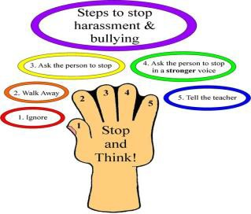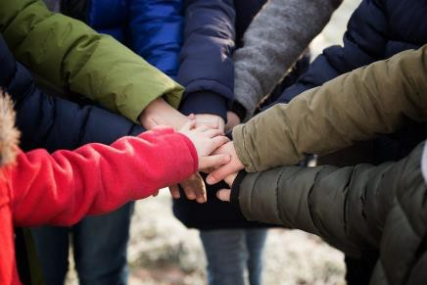

**If you are bullied:-**

**DO:-**

* Ask them to STOP if you can.
* Try and ignore them.
* Walk away.
* Talk to a friend.
* Tell a trusted adult.
* Keep any messages to show an adult

**DON’T:-**

* Don’t what they say.
* Try not to get angry or look upset.
* Don’t hit them.
* Bullying is not your fault.
* Don’t hide your feelings
* Don’t reply to cyber bulling.

**What should I do if I see someone else being bullied?**

* Tell an adult straight away.
* Don’t try and get involved – you might end up getting hurt or you could end up in trouble yourself.
* Don’t stay silent or the bullying will keep happening.
* By-standers are really important to stop bullying from happening.

**The Head, the Governors and the staff will work together to: -**

* Make our school a place where everyone can feel safe and happy. That means no bullying allowed.
* We will help everyone to get on with each other and we believe that everyone has the right to be who they are.

**What will happen to a bully?**

We will work with the bullying and do something called **restorative work** to show the bully that they need to stop and why this is not okay.

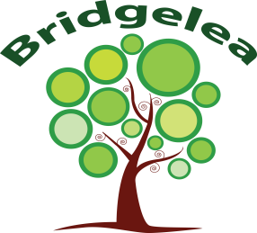

**Bridgelea Primary School**

Article 39: The right to help if you’ve been hurt, neglected or badly treated

**Child Friendly Anti-Bullying Policy 2023/2025**

**When is it bullying?**

**We promise to always treat bullying seriously. We will support the victim of bullying with your emotions and work with the bully to stop and see why their actions are hurtful. We will tell the victim what have done to help.**

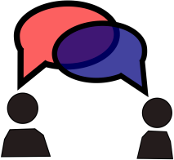

**Who can I tell?**

**MOST IMPORTANTLY:-**

If you are being bullied:

**Start Telling Other People**

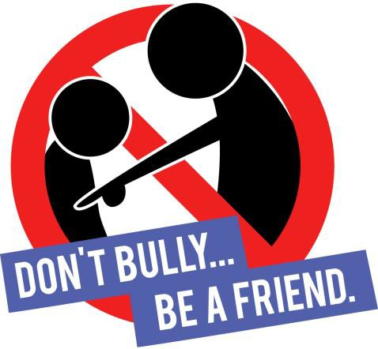

**What is Bullying?**

A bully is someone who hurts someone else by using behaviour which is meant to hurt, frighten or upset another person. This behaviour is **repeated frequently.**

**Emotional:** Hurting people’s feelings, leaving you out;

**Physical:** Punching, kicking, spitting, hitting, pushing;

**Verbal:** Being teased, name calling; **Cyber:** Saying unkind things by text, e-mail and online;

**Racist**: Calling you names because of the colour of your skin or religious and homophobic beliefs.

|  |
| --- |
| **Several** |
| **Times** |
| **On** |
| **Purpose** |

|  |
| --- |
| * A Friend * Parents & carers * Teachers and other schools staff * School friends * Another adult |
| * [ChildLine:](http://www.childline.org.uk/) ChildLine is the UK's free, confidential helpline for children and young people. They offer advice and support, by phone and online, 24 hours a day. Whenever and wherever you need them, they'll be there. Call 0800 1111. |
|  |
|  |
| * The Bus Escort |
| * Any Other Adult |