|  |  |
| --- | --- |
|  | |
| Bridgelea Primary School  Bridgelea Road  Withington  M20 3FB | Bridgelea Primary School  Plymouth Grove West  Longsight  M13 0AQ |
| **Anti-Bullying Policy**  Take A Stand Lend A Hand Stop Bullying Now " Poster for Sale by AlphaDist2  | Redbubble | |

|  |  |
| --- | --- |
| **Presented by** | **Caroline Gibson** |
| **Ratified by Governors** | **March 2023** |
| **Review Date** | **March 2025** |

# “Understanding People”

At Bridgelea school we want to help our children, families, and communities to understand themselves and others more. As a Nurture school, we feel that the nurture principles and approaches support us todevelop and embed a nurturing culture throughout the school, enhancing teaching and learning, promoting healthy outcomes for children and young people, all by focusing on emotional needs and development as well as academic learning in a whole-school environment.

As a gold Rights Respecting School children's rights are promoted and realised, adults and children work together to ensure children can access their rights. A Gold Rights Respecting School is a place where we can all feel confident with ourselves, and it encourages us to use our voice.

* Pupils benefit from the approach that supports them in their specific needs while delivering teaching and learning in a way that all can access. The pupil is at the heart of our focus and their learning is understood developmentally.
* Parents and carers benefit from being involved and welcomed at Bridgelea, in seeing the improvement in the children’s learning, behaviour, confidence, and attendance. A better outcome for their children both in and out of the school and classroom.
* Staff benefit from focusing on their pupils and a more balanced measure of outcomes for individual pupils ensue.
* Our community, Manchester, benefits from having a school that wants to be at the heart of the community and demonstrates its central role in children's and young people’s lives.

Our values reflect our main principle; Nurture. We believe that all of our children and young people deserve the best education possible and we do this by creating the conditions for them to thrive.

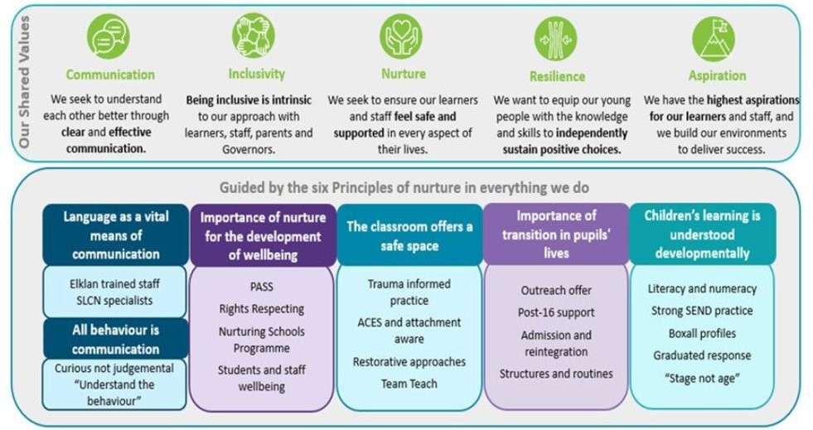

**UN Rights of the Child: Bridgelea 10 Articles**

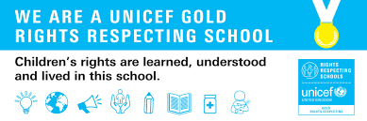

**Article 12**

You have the right to give your opinion, and for adults to listen and take it seriously.

**Article 13**

You have the right to find out things and share what you think with others, by talking, drawing, writing or in any other way unless it harms or offends other people.

**Article 15**

You have the right to choose your own friends and join or set up groups, as long as it isn't harmful to others.

**Article 24**

You have the right to the best health care possible, safe water to drink, nutritious food, a clean and safe environment, and information to help you stay well.

**Article 27**

You have the right to food, clothing, a safe place to live and to have your basic needs met. You should not be disadvantaged so that you can't do many of the things other kids can do.

**Article 28**

You have the right to a good quality education. You should be encouraged to go to school to the highest level you can.

**Article 29**

Your education should help you use and develop your talents and abilities. It should also help you learn to live peacefully, protect the environment and respect other people.

**Article 30**

You have the right to practice your own culture, language and religion - or any you choose. Minority and indigenous groups need special protection of this right.

**Article 31**

You have the right to play and rest.

**Article 39**

You have the right to help if you've been hurt, neglected or badly treated.

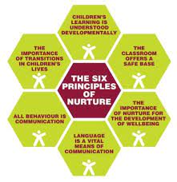

**The Six Principles of Nurture**

The nurturing approach offers a range of opportunities for children and young people to engage with missing early nurturing experiences, giving them the social and emotional skills to do well at school and with peers, develop their resilience and their capacity to deal more confidently with the trials and tribulations of life, for life.

**Rationale**

Everyone has the right to feel safe at school (Nurture Principle : Classroom is a safe base) and therefore bullying is unacceptable. Article 12 of the UNCRC states that children have the right to an opinion and adults should listen to children and take them seriously. Adults should take children’s disclosure of bullying seriously and take appropriate action. Pupils who feel they are being bullied will be supported. Pupils who bully others will also be supported to understand the impact of their actions. We understand that the role of **bystander** is key to tackling bullying.

**Development**

This policy has been developed in consultation with the whole staff team, parents and children in November 2022.

**What is bullying**

There’s no legal definition of bullying.

However, it’s usually defined as behaviour that is:

* repeated
* intended to hurt someone (either physically or emotionally)
* aimed at certain groups, for example because of race, religion, gender or sexual orientationIt takes many forms and can include:
* physical assault
* teasing
* making threats
* name calling
* cyber-bullying – bullying via mobile phone or online (for example email, social networks and messenger apps)If you’re based in the United Kingdom, the government states your school should have its own policy to stop bullying.

**An easy definition of bullying for students and parents**

The following useful acronym is a simple and effective way to teach children about the repetitive, persistent nature of bullying:

**S**everal  
**T**imes  
**O**n  
**P**urpose

[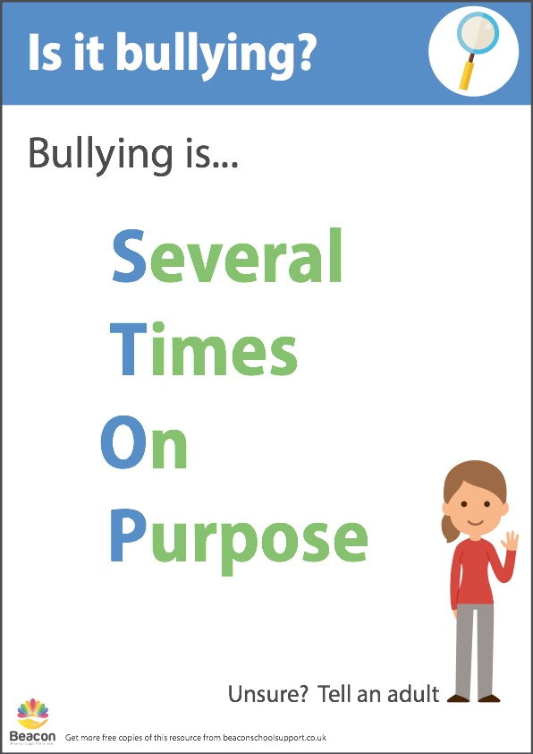](https://beaconschoolsupport.co.uk/articles/2017/11/antibullying_stop_poster.pdf)

**The Anti Bullying Alliance** defines bullying as:

Bullying is the repetitive, intentional hurting of one person or group by another person or group, where the relationship involves an imbalance of power. It can happen face to face or online.

**What are the different types of bullying?**

* **Verbal Bullying**: name calling, use of threatening or provocative language, making offensive remarks.
* **Psychological Bullying:** excluding an individual from group play, refusing to talk to someone, spreading rumours about someone.
* **Physical Bullying:** hitting, kicking, grabbing an individual, taking or hiding another’s property.

* **Cyber Bullying:** using the Internet or mobile phones to send hurtful or threatening messages.
* **Discrimination:** Some types of bullying can be against a group to which people may belong, for example, racial comments, bullying because of a person’s religious beliefs, gender, homophobic and sexualised bullying or bullying because of people that have special educational needs or disabilities.

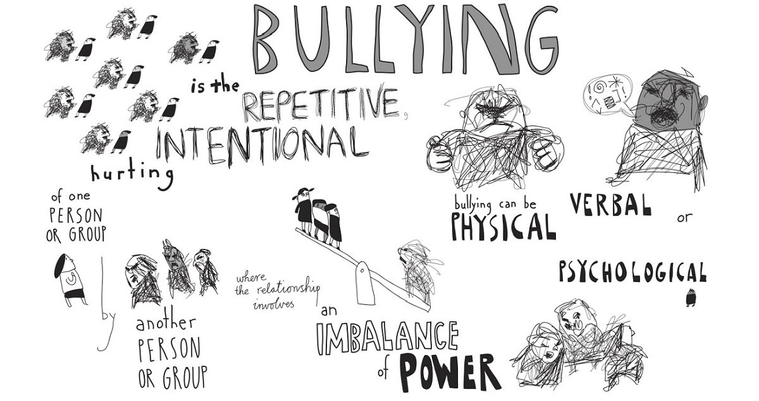

**What happens when someone is being bullied?**

Children who are being bullied or see bullying happen should tell their teacher or a trusted adult. In a recent pupil voice activity, children reinforced that staff at Bridgelea make them feel safe and they feel that they should tell a teacher if they are being bullied.

Members of staff must record bullying incidents on CPOMS and detail information about bullying and actions taken logged in the actions.

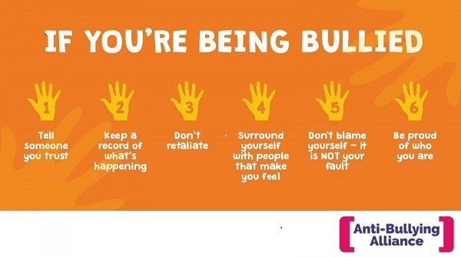

The language used around bullying can be very emotive and can ‘label’ children, suggesting permanence. Instead of ‘victim’ say person (child) who is being bullied, and instead of ‘bully’ say person (child) who is using bullying behaviours/doing the bullying. In this way it is the behaviours and roles that are being labelled, not the children.

Friendship problems and bullying behaviour can be upsetting and unpleasant but it is important to distinguish between the two, as the responses to friendship problems will be different to the strategies used to address bullying behaviour.

Friendship problems may be an occasional incident where both pupils disagree and find it difficult to resolve the disagreement without adult help. It is unlikely to be repeated behaviour and may even be accidental, where both children make an effort to resolve the problem. However, we recognise that repeated friendship problems can sometimes lead to bullying behaviour.

Bullying involves dominance of one student by another, or a group of others, is premeditated and usually forms a pattern of behaviour. It is behaviour which is intended to hurt, threaten or otherwise intimidate another person and can result in pain and distress to the victim in a physical or mental form.

Bullying is therefore:

* Deliberately hurtful;
* Repeated, often over a period of time;
* Difficult for victims to defend themselves against.

## **Cyberbullying**

The ever increasing use of digital technology and the internet has also provided new and particularly intrusive ways for bullies to reach their victims.

Cyberbullying can take many forms and bullying online can often start in school and then be progressed online or start online and influence behaviour in school.

Whilst most incidents of Cyberbullying occur outside school we will offer support and guidance to parents/carers and their children who experience online bullying and will treat Cyberbullying with the same severity as any other forms of bullying.

When responding to cyberbullying concerns, the we will:

* Act as soon as an incident has been reported or identified.
* Provide appropriate support for the person who has been cyberbullied and work with the person who has carried out the bullying to ensure that it does not happen again.
* Encourage the person being bullied to keep any evidence (screenshots) of the bullying activity to assist any investigation.
* Take all available steps where possible to identify the person responsible. This may include:
* identifying and interviewing possible witnesses;
* Contacting the service provider and the police, if necessary.
* Work with the individuals and online service providers to prevent the incident from spreading and assist in removing offensive or upsetting material from circulation. This may include:
* Supporting reports to a service provider to remove content if those involved are unable to be identified or if those involved refuse to or are unable to delete content.
* Confiscating and searching pupils’ electronic devices, such as mobile phones, in accordance with the law and DfE ‘Searching, screening and confiscation at school’ and Childnet cyberbullying guidance.
* Ensure that sanctions are applied to the person responsible for the cyberbullying; we will take steps to change the attitude and behaviour of the bully, as well as ensuring access to any additional help that they may need.
* Inform the police if a criminal offence has been committed.
* Provide information to staff and pupils regarding steps they can take to protect themselves online. This may include:
* advising those targeted not to retaliate or reply;
* providing advice on blocking or removing people from contact lists;
* helping those involved to think carefully about what private information they may have in the public domain.

We will ensure that our children are taught safe ways to use the internet (see our online safety policy) and encourage good online behaviour as part of the schools PHSE and computing curriculums.

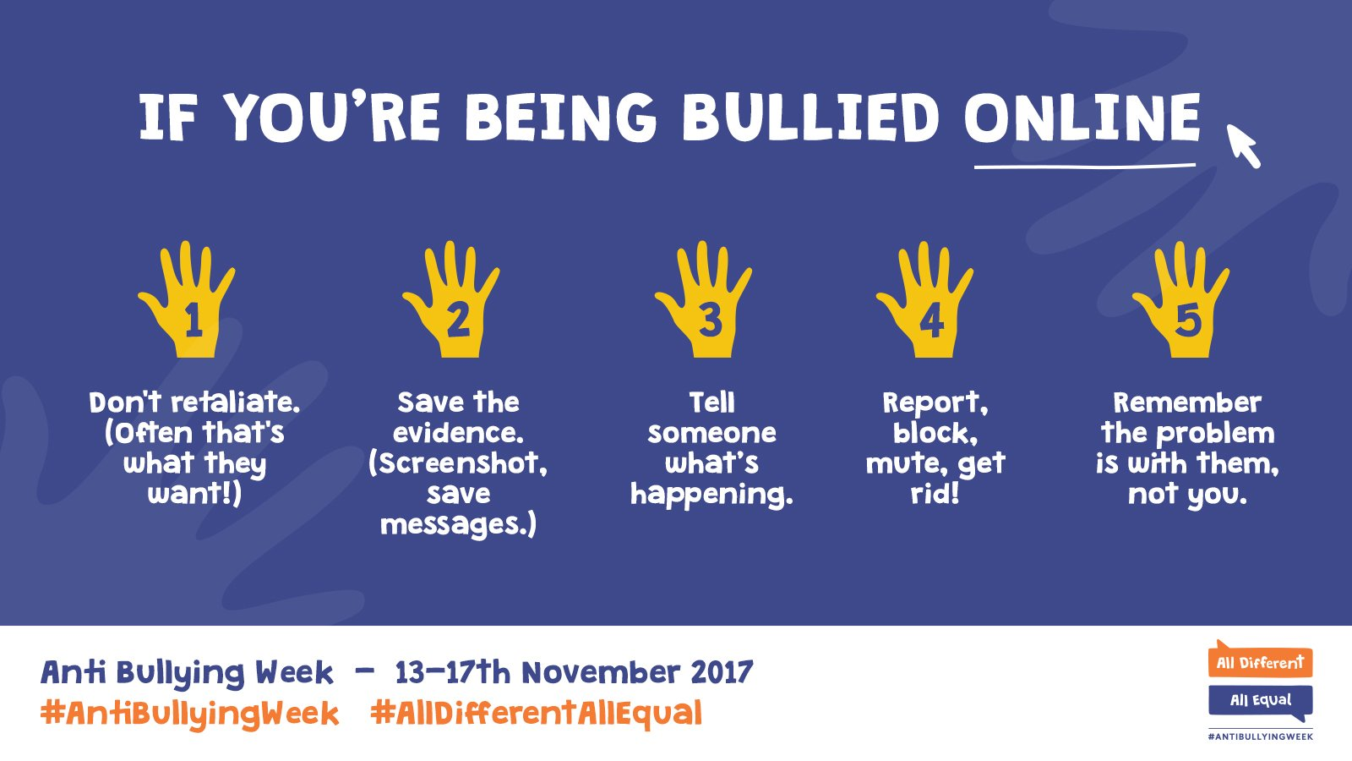

**Do children know what to do when bullying happens?**

Children across the school were asked to share their views on bullying. Children feel safe at Bridgelea. Some of the things that help them feel safe at school are:

* **Adults & teachers – some children have written names or drawn pictures of key adults in school.**
* **Having hugs**
* **Children and adults being nice and kind**
* **Toys and things to play with**
* **Safe base**
* **Small classrooms**
* **Having friends**
* **Floppy toast**
* **1:1 room**
* **Children have drawn pictures of their friends in school.**
* **Adults intervene when fights happen and keep you safe**
* **There is a safe base to keep you calm**
* **Adults offer you a minute on the green chairs – the school is really a safe school.**
* **Being around staff**
* **Leave me alone and give me space**
* **The teachers protect us and stop us getting hurt**
* **Listening to Music**
* **Compliments**

Children were able to reflect that the adults at Bridgelea support children if they are being bullied. In some cases, specific staff names were mentioned, and others were just “adults and Teachers in school”.

***Language is a vital form of communication so it is important that as adults we have a shared vocabulary we use when discussing bullying.***

* **“Bullying behaviour”** We understand children developmentally and recognise that all behaviour is communication. Therefore, it is important to describe the behaviour the child is displaying rather than labelling a child. Instead of calling a child a “bully”, using the term “bullying behaviour” supports us to understand that we can change this behaviour for the child and help them to make better, more socially appropriate choices with their peers.
* **Bystanders** Children need to understand the role of bystanders. Children at Bridgelea can complete the [bystanders](https://anti-bullyingalliance.org.uk/sites/default/files/uploads/attachments/Bullying%20roles%20activity.pdf) activity. This can be part of a whole class session in Key Stage Two or as a reactive resource to approach a bullying situation.
* **Restorative Practice** At Bridgelea we use restorative practice to support children to reflect on their behaviours, especially when these behaviours have been used in bullying incidents.
* **Repetitive –** Bullying is described as “Several Times on Purpose”, considering this, if a child has been targeted more than twice, staff should intervene and complete some targeted activities.

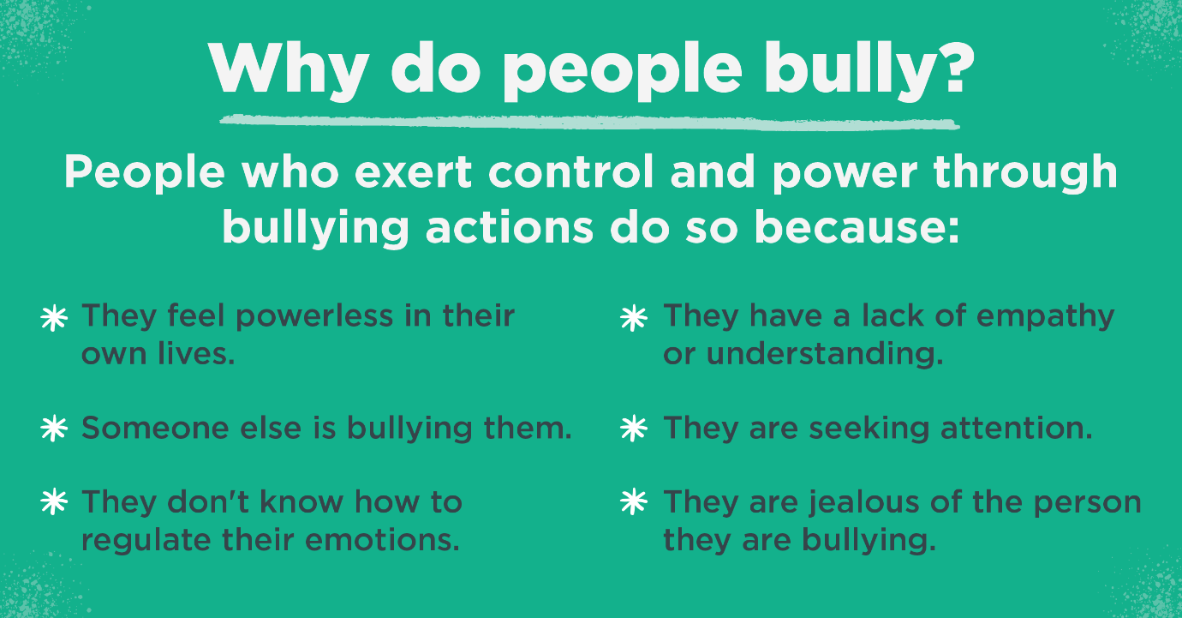

**What is Bridgelea’s Graduated Response to bullying?**

***Whole school prevention*** of bullying is key. As a Nurturing School we promote a positive learning environment and understand that all behaviour is communication. As the classroom is a safe base and the children have a right to a safe environment, we reinforce positive behaviour and role model positive choices through verbal and non-verbal cues.

At Bridgelea there is a plethora of resources to prevent bullying occurring:

* In a Pupil Voice activity children mentioned interventions and stories that can help prevent bullying.
* PSHE lessons – children learn about the consequences of bullying and are taught what to do if they see bullying or experience bullying.
* No Outsiders Curriculum Resources
* Anti-bullying week
* Rights Respecting Assemblies
* Rights Respecting ethos is built into daily scripts and reward systems
* Promoting friendships, empathy and kindness through curriculum offer
* Staff role modelling positive relationships
* Respect is modelled clearly
* Regular, positive praise that is explicitly directed to support children to reflect on their behaviour and relationships with others
* Discussions around the Nurture table at lunchtimes promote positive peer relationships.
* Visuals are displayed in class to remind children that bullying is not acceptable and of the actions they take if they are being bullied or are a by-stander.
* Whole class circle games and activities as a reactive tool if bullying behaviour or peer relationship difficulties begin. These can be used as a tool to limit these behaviours before they become bullying.

**If a child is being bullied?**

* Staff must log on CPOMS and speak to all children who are involved parents. The plan of action must be shared. All work must be recorded on CPOMS so that monitoring of engagement can be completed by SLT and floor leads.
* Targeted interventions that have a restorative approach to bullying must start immediately after the incident. This may be the very next day or even the next session if this is appropriate. A retreat referral can be made to access further support.
* As a Rights Respecting school, we remind children of their rights and that we should be respecting rights of others.
* The child who is displaying bullying behaviour will be removed from the classroom environment to complete these targeted interventions.
* Some examples of activities completed with children can be found here : [Antibullying activities](https://bridgeleaprimaryschool.sharepoint.com/:b:/s/RetreatTeam/EbtT9pAXmFBAsWb1SAqC2PEBUWapffYxTQBodkYRdXT-cw?e=9nSQBR) , [videos,](https://www.bbc.co.uk/teach/class-clips-video/pshe-ks2-text-bullying/zvgdt39)
* In addition to this : comic strip conversations & social stories are a useful tool to reflect on the bullying behaviour with the child and to support them to change their behaviour. This may need to be repeated regularly throughout the day.
* There are additional online bullying and safety resources on Purple Mash and [Project Evolve](http://projectevolve.co.uk).
* We also use the zones of regulation to support both children / groups of children to reflect on their behaviours.
* Children at Bridgelea feel that both parents of the bullied child and the child displaying bullying behaviour should be phoned. Both children should access support that is restorative in its approach.