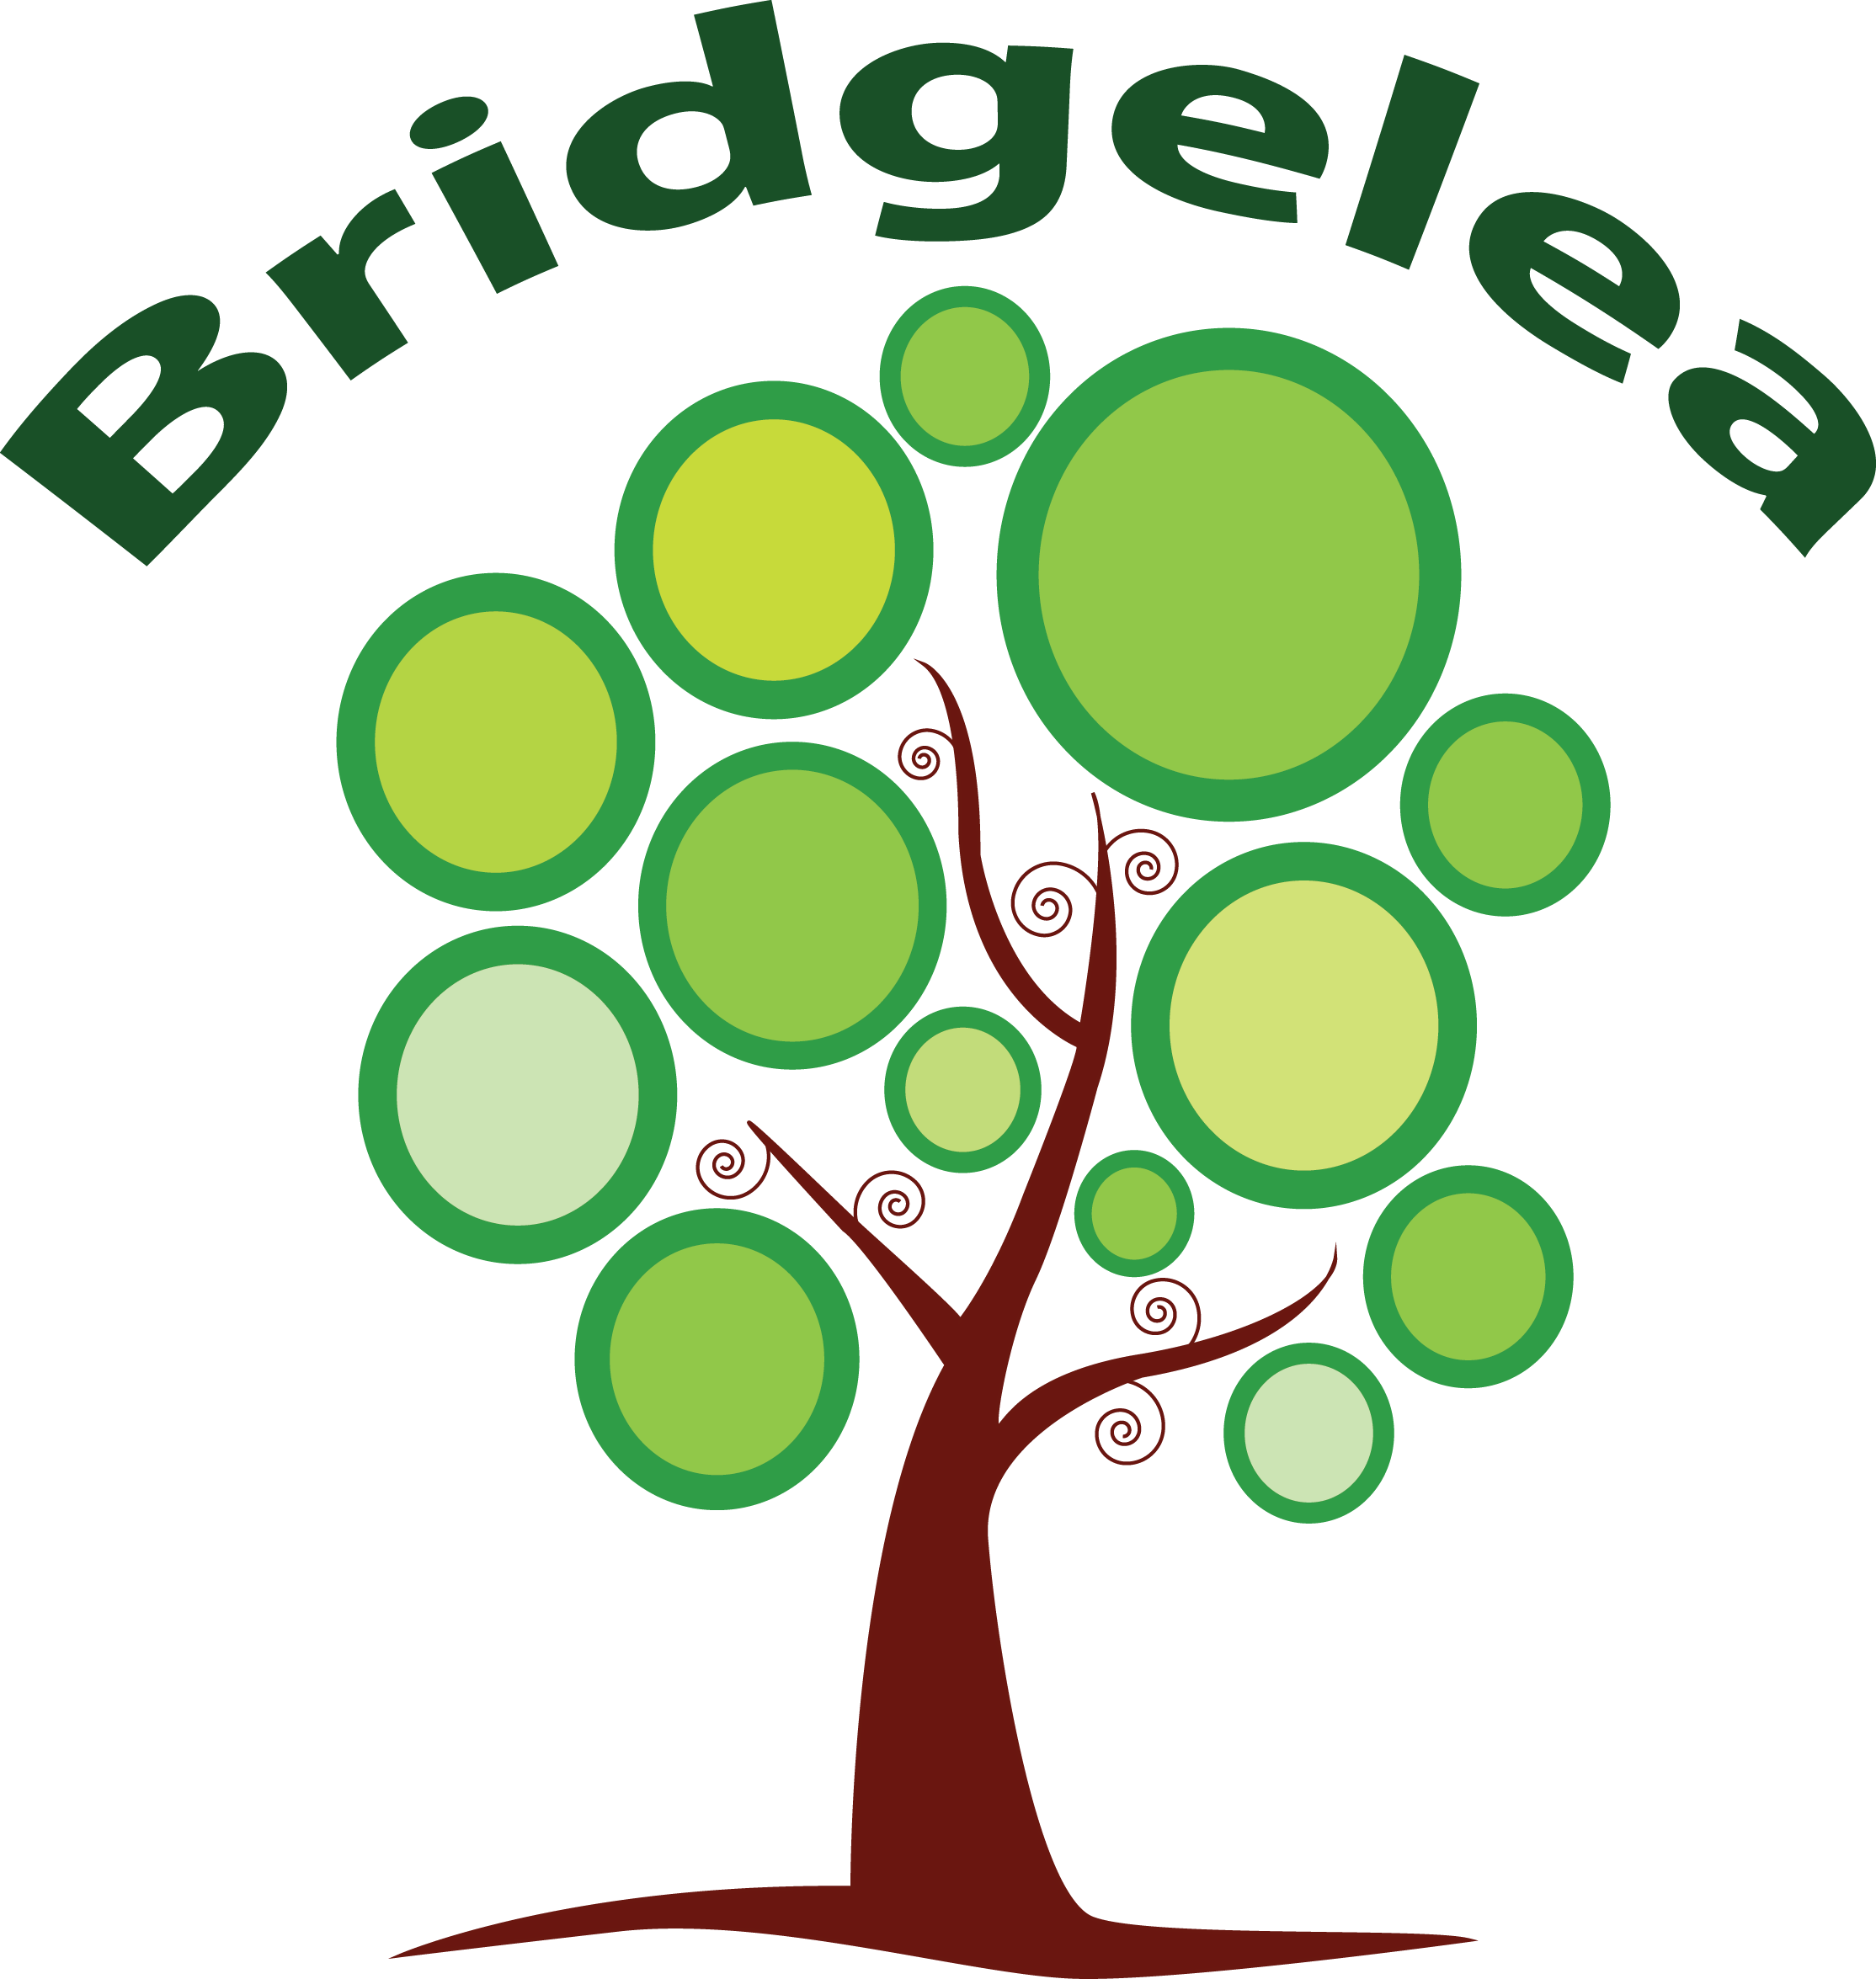

Bridgelea Primary School

Bridgelea Road

Withington
Manchester

M20 3FB

CHARGING & REMISSIONS POLICY

Implemented | January 2024
Presented by | School Business Manager
Ratified by Governors
Review Date | January 2026

Bridgelea Primary School Vision & Mission Statement

Our overall vision of 'Understanding People' captures our core purpose perfectly. At Bridgelea we want to help our children, families, and communities to understand themselves and others more, whilst keeping their understanding of the statutory and wider curriculum.
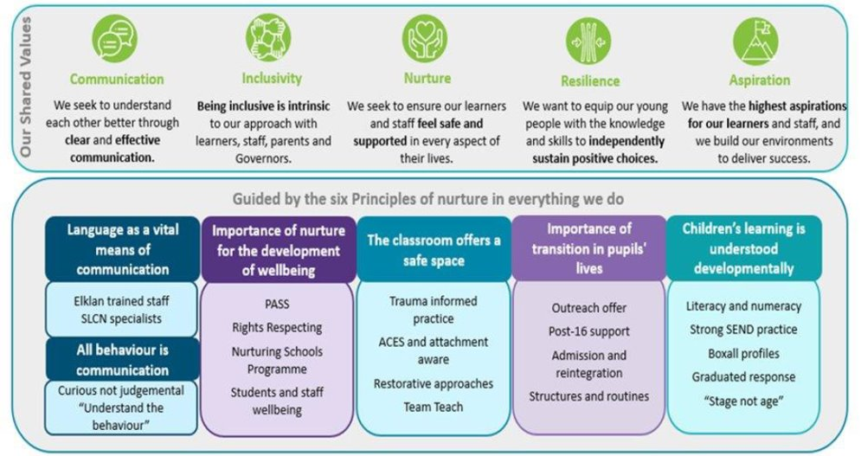

UN Rights of the Child: Bridgelea 10 Articles

Through the School Council the children decided they would like to focus on the following 10 Articles, whilst understanding no right is more important than another:

Article 12
You have the right to give your opinion, and for adults to listen and take it seriously.

Article 13
You have the right to find out things and share what you think with others, by talking, drawing, writing or in any other way unless it harms or offends other people.

Article 15
You have the right to choose your own friends and join or set up groups, as long as it isn't harmful to others.

Article 24
You have the right to the best health care possible, safe water to drink, nutritious food, a clean and safe environment, and information to help you stay well.

Article 27
You have the right to food, clothing, a safe place to live and to have your basic needs met. You should not be disadvantaged so that you can't do many of the things other kids can do.

Article 28
You have the right to a good quality education. You should be encouraged to go to school to the highest level you can.

Article 29
Your education should help you use and develop your talents and abilities. It should also help you learn to live peacefully, protect the environment and respect other people.

Article 30
You have the right to practice your own culture, language and religion - or any you choose. Minority and indigenous groups need special protection of this right.

Article 31
You have the right to play and rest.

Article 39
You have the right to help if you've been hurt, neglected or badly treated.

The Six Principles of Nurture

The nurturing approach offers a range of opportunities for children and young people to engage with missing early nurturing experiences, giving them the social and emotional skills to do well at school and with peers, develop their resilience and their capacity to deal more confidently with the trials and tribulations of life, for life.

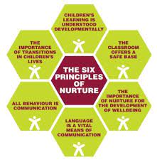

Introduction

This document sets out the Charging Policy of Bridgelea Primary School and provides information to parents on the circumstances where the school would charge for activities, whether these are within school hours or out of school hours. It also provides information on activities where no charge is made.

Educational Visits and Extra-curricular activities

The Management committee will support off-site activities which the Headteacher considers to be of good educational value and complementary to the curriculum. Where costs are involved, parents could be asked to contribute.

Bridgelea staff and transport costs will be met by school. If funds received are insufficient, the visit may be underwritten by the School, or cancelled, at the discretion of the Headteacher.

Voluntary Contributions for Non Curriculum Activities

When organising school activities that are not part of the curriculum but enrich the educational experience of the children, the school will invite parents to contribute to the cost of the activity.

These contributions are necessary to fund the activity but are voluntary as the school cannot make contributions mandatory. The level of contribution is decided by the Head Teacher and is designed to cover the cost of the activity without affecting the schools budget allocation. Staff costs will always be met by school as will vehicle costs.

There are circumstances where the school will contribute towards an activity, but if the school does not receive sufficient voluntary contributions, the school may decide to cancel the activity. If the activity goes ahead, it will include children whose parents have not paid any contribution. In these circumstances the school would not treat these children differently from any others.

Parents have a right to know how each trip is funded and the school will provide this information on request.

Residential Visits for Curriculum Activities

If the school organises a residential visit in school time or mainly school time, which is to provide education directly related to the National Curriculum, no charge is made for the education element. A charge may, however, be made to cover the costs of board and lodging. As a school we endeavour to try and limit any charges associated to curriculum.

Sports Activities

The school organises sporting activities for the pupils as part of the curriculum. These take place in school time and, and although they exceed the National Curriculum requirement, the school does not levy a charge to parents

School Damages or Breakages

In cases of wilful or malicious damage to school property, such as books, equipment, breakages, or loss of school books or equipment on loan to pupil the Headteacher in consultation with the School Business Manager may decide to make a charge. Each incident will be dealt with on its own merit and at their discretion.
Personal Lost/Stolen/Damaged Property

To clarify the school’s position regarding the care of personal items brought on to the school site by pupils and the procedures to be followed if personal items are lost, stolen or damaged.
Guidelines
1. The school accepts no responsibility for loss or damage to the personal property of pupils.
2. To minimise the possibility of property being lost, stolen or damaged:
- All pupils and their parents are asked to make sure that all items of clothing and equipment, where possible, are suitably labelled with your child’s full name so that lost property can be returned to its owner as soon as possible. Any named items found will be kept in the lost property box.
- Pupils are asked not to bring valuable items of clothing or large sums of money to school.
- Money and valuable items must never be left unattended in classrooms or bags or unattended around the school site.
- Pupils are not allowed to use mobile phones or watches with a mobile function in school. If worn they will need to be stored in the zip wallets with the mobile phones as described in the next bullet point.
- Personal items brought into school to support on transitions for transport are placed in zip wallets in a storage box on arrival. This is at the pupil and parents own risk.

3. It is recommended pupils do not wear high value clothing to school.
4. All valuable items can be handed into reception and given back at the end of the day.
5. All lost property will be handed into reception.
6. Any school books or equipment issued to a pupil become their responsibility. If lost, damaged or stolen the parent/guardian is responsible for the replacement.

Uniform

Uniform is available for parents to buy at a subsidised rate. School does not accept responsibility for lost or damaged articles of clothing or any personal possessions. All prices are to be reviewed annually.

Remissions

Where the parents of a pupil are in receipt of state benefits which would entitle their child to receive free school meals the Management Committee will remit the majority of the cost of board and lodgings for any residential activity. This is made clear in all correspondence in relation to these activities.

