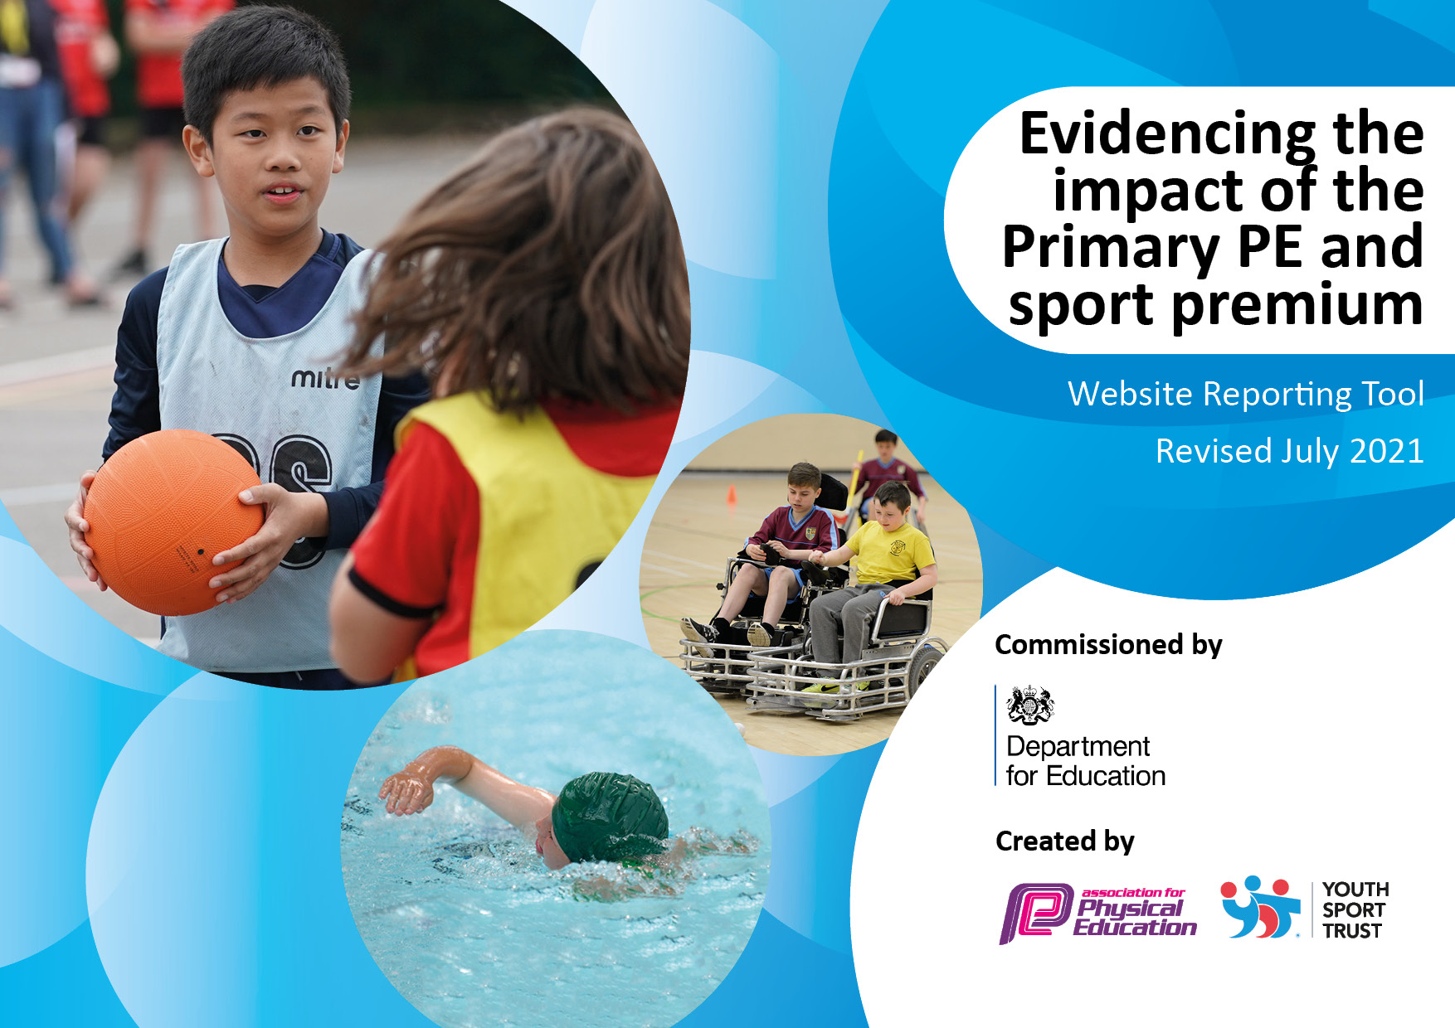

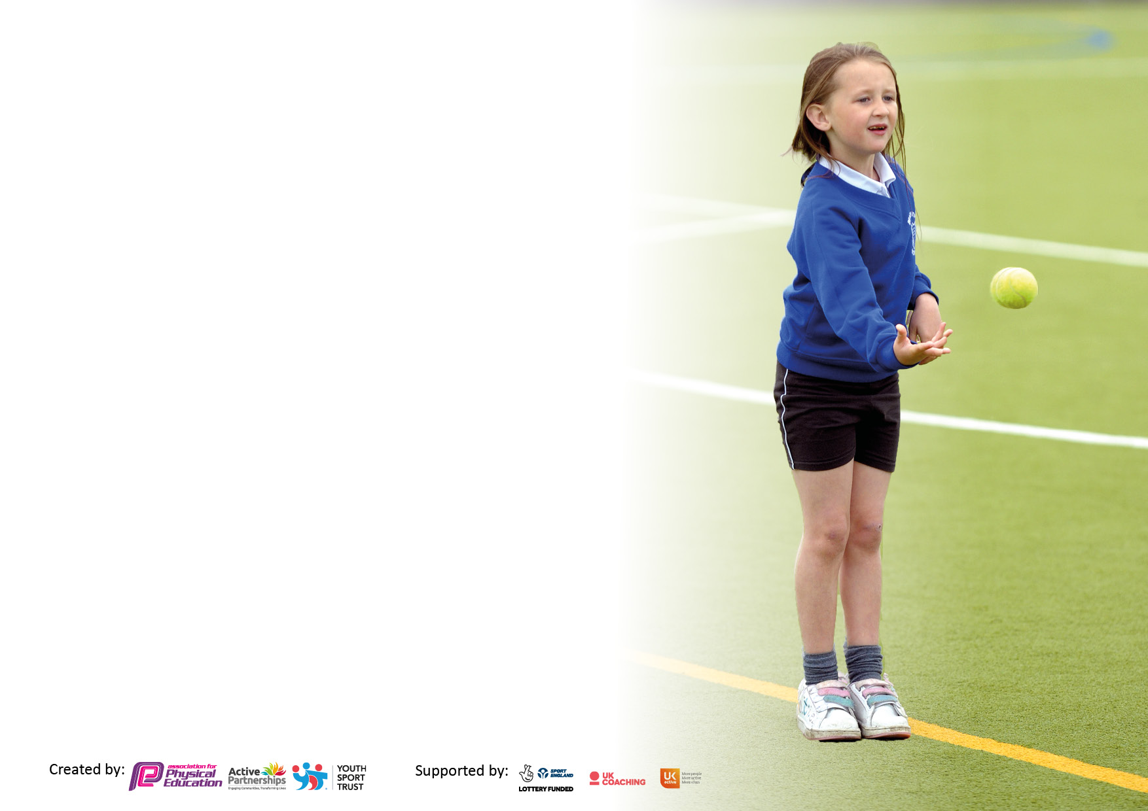

It is important that your grant is used effectively and based on school need. The Education Inspection Framework makes clear there will be a focus on **‘whether leaders and those responsible for governors all understand their respective roles and perform these in a way that enhances the effectiveness of the school’**.

Under the Quality of Education Ofsted inspectors consider:

**Intent** - Curriculum design, coverage and appropriateness

**Implementation** - Curriculum delivery, Teaching (pedagogy) and Assessment

**Impact** - Attainment and progress

To assist schools with common transferable language this template has been developed to utilise the same three headings which should make your plans easily transferable between working documents.

Schools must use the funding to make **additional and sustainable** improvements to the quality of Physical Education, School Sport and Physical Activity (PESSPA) they offer. This means that you should use the Primary PE and sport premium to:

* Develop or add to the PESSPA activities that your school already offer
* Build capacity and capability within the school to ensure that improvements made now will benefit pupils joining the school in future years
* The Primary PE and sport premium should not be used to fund capital spend projects; the school’s budget should fund these.

Please visit gov.uk for the revised DfE guidance including the 5 key indicators across which schools should demonstrate an improvement.

This document will help you to review your provision and to report your spend.DfE encourages schools to use this template as an effective way of meeting the reporting requirements of the Primary PE and sport premium.

We recommend you start by reflecting on the impact of current provision and reviewing the previous spend.

Schools are required to publish details of how they spend this funding, including any under-spend from 2019/2020, as well as on the impact it has on pupils’ PE and sport participation and attainment. **All funding must be spent by 31st July.**

We recommend regularly updating the table and publishing it on your website throughout the year. This evidences your ongoing self-evaluation of how you are using the funding to secure maximum, sustainable impact. Final copy must be posted on your website by the end of the academic year and no later than the 31st July 2021.

**Details with regard to funding**

Please complete the table below.

|  |  |
| --- | --- |
| Total amount allocated for 2023/24 | £ 16,760 |
| Total amount carried over from 2022/23 | £ 1,835 |
| Total amount of funding for 2023/24. To be spent and reported on by 31st July 2024. | £ 18,595 |
| Total amount allocated for 2024/25 | £16,760 |
| Total amount carried over from 2023/24 | £3,259 |
| Total amount of funding for 2024/2025. To be spent and reported on by 31st July 2025. | £20, 019 |

**Swimming Data**

Please report on your Swimming Data below.

|  |  |
| --- | --- |
| At Bridgelea we use the premium to raise attainment in school swimming and water safety by funding top-up swimming sessions for those children that do not meet national curriculum requirements after they’ve completed core swimming lessons. | |
| Meeting national curriculum requirements for swimming and water safety. **Due to exceptional circumstances priority should be given to ensuring that pupils can perform safe self-rescue even if they do not fully meet the first two requirements of the NC programme of study** | |
| What percentage of your current Year 6 cohort swim competently, confidently and proficiently over a distance of at least 25 metres? **N.B.** Even though your pupils may swim in another year please report on their attainment on leaving primary school at the end of the summer term 2024. | 0% |
| What percentage of your current Year 6 cohort use a range of strokes effectively? | 0% |
| **What percentage of your current Year 6 cohort perform safe self-rescue in different water-based situations?** | 0% |
| Schools can choose to use the Primary PE and sport premium to provide additional provision for swimming but this must be for activity **over and above** the national curriculum requirements. Have you used it in this way? | Yes |

**Action Plan and Budget Tracking**

Capture your intended annual spend against the 5 key indicators. Clarify the success criteria and evidence of impact that you intend to measure to evaluate for pupils today and for the future.

|  |  |  |  |  |
| --- | --- | --- | --- | --- |
| **Academic Year:** 2023/24 | **Total fund allocated:** £18,594 | **Date Updated:** June 2024 | | Predicated Percentage of total allocation: 32%  Actual Percentage of total allocation: 37% |
| **Key indicator 1:** The engagement of all pupils in regular physical activity – Chief Medical Officers guidelines recommend that primary school pupils undertake at least 30 minutes of physical activity a day in school | | | |
| **Intent** | **Implementation** | | **Impact** | |
| Raising attainment in swimming to meet requirements of the national curriculum before the end of Key stage 2. | Two weekly swimming lessons to be shared equally between Withington and Longsight. | Predicted Spend: £6,822.  Actual Spend- £6868 | Low percentage of national curriculum requirement for swimming.  No/low levels of external swimming by parents/carers.  Swimming taught across KS2 due to different arrival times of pupils, this to be changed for 24/25 academic year with a larger focus on achieving the national curriculum outcomes. | |
| To increase the focus on allowing children to access personal best activities. Focus on children challenging themselves. Can they get better? Can they go away from school and work to focus these in PE lessons. | Examples: Cross Country, Bleep Test Fitness circuits. JC to lead on improving a chosen skill.  KS2 children will have the option of 1 additional PE lesson per term to record personal best scores with improvement being monitored.  Links to Skills for Life | JC cover  £1,380  Actual Spend  £0 | This was not possible due to staff impact | |

|  |  |  |  |  |
| --- | --- | --- | --- | --- |
| **Key indicator 2:** The profile of PESSPA being raised across the school as a tool for whole school improvement | | | | Predicted Percentage of total allocation: 9.8%  Actual Percentage of total allocation: 5% |
| **Intent** | **Implementation** | | **Impact** | |
| School PE (OAA) enrichment activities. | Canoeing (Debdale)  Rock climbing (Hide out)  To reapply and run HAF programmes for all FSM children plus any child targeted by school.  Links to Skills for Life | Predicted  £1,106  £720  Actual Spend: £556 | Canoeing and Rock Climbing: This is planned for the Summer Term 2024.  A range of activities including cycling, climbing, skateboarding and trampolining. £556  Canoeing extremely well received by staff and pupils. Allowed pupils OAA opportunities not available at home.    Rock climbing had a low level of involvement from pupils. Sessions were also used as alternative curriculum session. | |

|  |  |  |  |  |
| --- | --- | --- | --- | --- |
| **Key indicator 3:** Increased confidence, knowledge and skills of all staff in teaching PE and sport | | | | Predicted Percentage of total allocation: 8.1%  Actual Percentage of total allocation: 8.9% |
| **Intent** | **Implementation** | | **Impact** | |
| Providing staff with mentoring & CPD to teach sport and PE more effectively. | PE lead to lead training for Class Teachers to be upskilled from observing/partaking lessons.  Staff feel more confident delivering various PE sessions. | £1,500 | This was not possible due to absence/staff recruitment. We have instead commissioned commando jo to deliver a physical activity  Total Cost- Commando Jo- £12,000  FY 23/24- £4000  FY 24/25- £8000  10% is to deliver training to staff for active playtimes.  £400- 23/24  £800- 24/25  £1200 over two years | |

|  |  |  |  |
| --- | --- | --- | --- |
| **Key indicator 4:** Broader experience of a range of sports and activities offered to all pupils | | | Predicted Percentage of total allocation: 45.1%  Actual Percentage of total allocation: 38% |
| **Intent** | **Implementation** | | **Impact** |
| To support children in Y5 to access a high quality outdoor learning opportunity  Ghyll Head Residential | Introducing new sports or activities to encourage more pupils to take up sport. | £2,500 | 6 staff attend Ghyll where they claim half a day TOIL each.  Ghyll Head- £7048 - 2 visits.  Extremely well received by staff and pupils. Allowed pupils OAA opportunities not available at home. |
| Providing staff with resources to teach sport and PE more effectively and embed physical activity/PE across the school. | Continue to develop the stock of PE equipment to reflect the introduction of an adapted PE scheme. | £2,500 | £520 spent on resources and £30 on training = £550 |
| Deliver effective dance lessons and upskill current staff. | Hire dance teacher. Children will get dance coaching by a specialist in that field. | £2,000 | Did not happen due to recruitment. We could not find anyone suitable. |
| Total Spend | Available to spend: £18,594  Total: 15,422  Underspend: £3259 | | |

|  |  |  |  |  |
| --- | --- | --- | --- | --- |
| **Academic Year:** 2023/24 | **Total fund allocated:** £20, 019 | **Date Updated:** June 2024 | | Percentage of total allocation: 39% |
| **Key indicator 1:** The engagement of all pupils in regular physical activity – Chief Medical Officers guidelines recommend that primary school pupils undertake at least 30 minutes of physical activity a day in school | | | |
| **Intent** | **Implementation** | | **Impact** | |
| Raising attainment in swimming to meet requirements of the national curriculum before the end of Key stage 2. | Two weekly swimming lessons to be shared equally across the top floor- review at each half term to discuss which Y6 children have achieved 25m. | Predicted Spend: £7045 |  | |
| To increase the focus on allowing children to access personal best activities. Focus on children challenging themselves. Can they get better? Can they go away from school and work to focus these in PE lessons. | Examples: Cross Country, Bleep Test Fitness circuits. JC to lead on improving a chosen skill.  KS2 children will have the option of 1 additional PE lesson per term to record personal best scores with improvement being monitored.  Links to Skills for Life | JC cover £0 |  | |
| To use physical ways to teach Maths | Teach Active Maths  1 year subscription to introduce the approach | £780 |  | |

|  |  |  |  |  |
| --- | --- | --- | --- | --- |
| **Key indicator 2:** The profile of PESSPA being raised across the school as a tool for whole school improvement | | | | Percentage of total allocation: 16% |
| **Intent** | **Implementation** | | **Impact** | |
| School PE (OAA) enrichment activities. | Canoeing (Debdale)  To reapply and run HAF programmes for all FSM children plus any child targeted by school.  Links to Skills for Life | Canoeing: 1500  Skateboarding: £1260  Additional OAA Activities- £494 |  | |

|  |  |  |  |  |
| --- | --- | --- | --- | --- |
| **Key indicator 3:** Increased confidence, knowledge and skills of all staff in teaching PE and sport | | | | Percentage of total allocation: 4% |
| **Intent** | **Implementation** | | **Impact** | |
| Providing staff with mentoring & CPD to teach sport and PE more effectively. | PE lead to lead training for Class Teachers to be upskilled from observing/partaking lessons.  Staff feel more confident delivering various PE sessions. | Total Cost- Commando Jo- £12,000  FY 23/24- £4000  FY 24/25- £8000  10% is to deliver training to staff for active playtimes.  £400- 23/24  £800- 24/25  £1200 over two years |  | |

|  |  |  |  |
| --- | --- | --- | --- |
| **Key indicator 4:** Broader experience of a range of sports and activities offered to all pupils | | | Percentage of total allocation: 30% |
| **Intent** | **Implementation** | | **Impact** |
| To support children in Y5 to access a high-quality outdoor learning opportunity  Ghyll Head Residential (GLL) | Introducing new sports or activities to encourage more pupils to take up sport. | £4,000 |  |
| Providing staff with resources to teach sport and PE more effectively and embed physical activity/PE across the school. | Continue to develop the stock of PE equipment to reflect the introduction of an adapted PE scheme.  AMV Playgrounds to fit the basketball net. | £2,250 |  |
| Children to have access to simply cycling to support motor skills and coordination | Fortnightly Simply Cycling Trip (Withington and Ground Floor) | £1890 |  |
| Head Teacher: | | | |
| Date: | | | |
| Subject Leader: | | | |
| Date: | | | |
| Governor: | | | |
| Date: | | | |