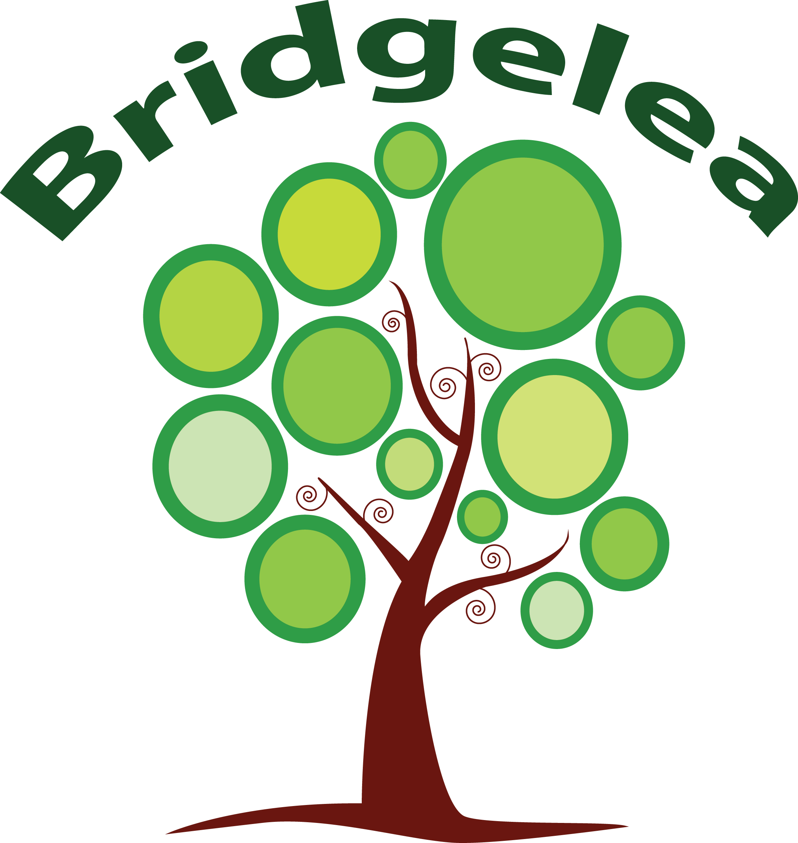

|  |  |
| --- | --- |
| Bridgelea Primary School  Bridgelea Road  Withington Manchester  M20 3FB | Bridgelea Primary School  Plymouth Grove West  Longsight Manchester  M13 0AQ |

|  |
| --- |
| **Behaviour, Communication**  **and Relationships Policy**  **with Statement of Behaviour Principles** |

**Article 12**

You have the right to give your opinion, and for adults to listen and take it seriously.

**Article 28**

You have the right to a good quality education. You should be encouraged to go to school to the highest level you can.

**Article 29**

Your education should help you use and develop your talents and abilities. It should also help you learn to live peacefully, protect the environment and respect other people.

**Article 31**

You have the right to play and rest.

**Article 39**

You have the right to help if you've been hurt, neglected or badly treated.

Skills for Life:

**Table of Contents**

Rights Respecting School 6

The Duty Bearer’s Role 6

Floor Charters 6

Developing trusting relationships with staff, children, and parents/carers 9

Praise and positive reinforcement – ‘catching children getting it right’ 9

Responding as role models and using positive phrasing 9

Consistency and consistent use of scripts. 10

Routines, repetition, and structure with established clear and agreed boundaries/expectations 10

Transitions are seen as important and managed carefully for all children 10

Comfort, forgiveness and restorative processes. 10

Legislation and Statutory Requirements 11

Definitions 11

Roles and Responsibilities 15

The governing board 15

The headteacher 15

Staff 15

Parents 15

Creating a Positive Ethos 16

The Role of Rewards and Celebration 16

Class Dojo / School Spider 17

Zones of Regulation 17

Logical Consequences 17

Retreat 18

Restorative Approaches 18

Unsociable Behaviour 20

Antisocial Behaviour 21

Safeguarding 23

Responding to misbehaviour 23

Reasonable force 23

Searching, screening and confiscation 24

Confiscation 24

Searching a pupil 24

Searching pupils’ possessions 26

Informing the designated safeguarding lead (DSL) 26

Informing parents/carers 26

Support after a search 26

Strip searches 27

Communication and record-keeping 27

Who will be present 27

Care after a strip search 28

Screening 28

Off-site misbehaviour 28

Online misbehaviour 29

Suspected criminal behaviour 29

Zero-tolerance approach to sexual harassment and sexual violence 29

Malicious allegations 30

Removal from classrooms 30

Suspension and permanent exclusion 31

Levels of Response: 32

Level 1 32

Level 2 32

Level 3 32

Post Incident Learning 33

Serious Incidents and Logical Consequences 34

Reduced Timetables 35

Circumstances where it might be considered 35

Safeguarding 35

Absconding 36

A Reintegration Plan 36

A Safety and Support Plan 36

Sexual Harrassment and/or Violence 38

Malicious Allegations 38

Confiscation 38

Child Protection 39

Monitoring arrangements 39

Governor Consultation 39

Parental Consultation 39

Staff Consultation 39

Appendix 1: Written Statement of Behaviour Principles 40

Appendix 2 Graduated Response 41

Appendix 3 43

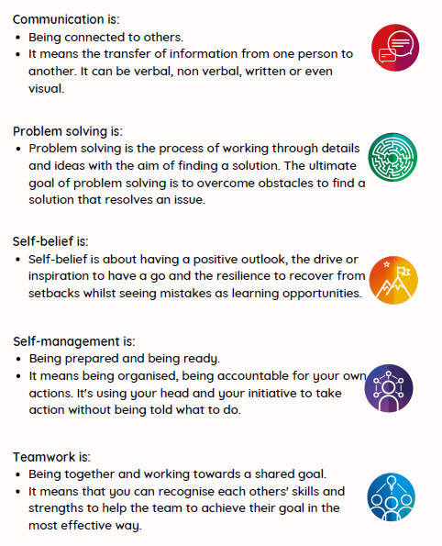

|  |  |
| --- | --- |
| **Implemented** | **SLT** |
| **Presented by** | **Kelly Eyre** |
| **Ratified by Governors** | * **Staff, Pupil & Parent Consult Summer 2024** * **Governors Autumn 2024** |
| **Review Date** | **Summer 2025** |

|  |
| --- |
| **Bridgelea Primary School Vision & Mission Statement** |

Our overall vision of '**Understanding People**' captures our core purpose perfectly. At Bridgelea we want to help our children, families, and communities to understand themselves and others more, whilst keeping their understanding of the statutory and wider curriculum.

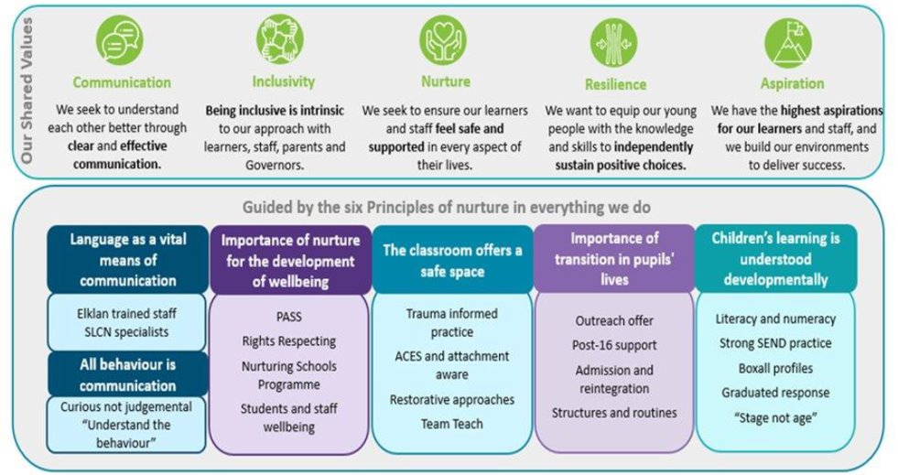

|  |
| --- |
| **Gold Rights Respecting School** |

Through the School Council the children decided they would like to focus on the following 10 Articles, whilst understanding no right is more important than another:

**Article 12**

You have the right to give your opinion, and for adults to listen and take it seriously.

**Article 13**

You have the right to find out things and share what you think with others, by talking, drawing, writing or in any other way unless it harms or offends other people.

**Article 15**

You have the right to choose your own friends and join or set up groups, if it isn't harmful to others.

**Article 24**

You have the right to the best health care possible, safe water to drink, nutritious food, a clean and safe environment, and information to help you stay well.

**Article 27**

You have the right to food, clothing, a safe place to live and to have your basic needs met. You should not be disadvantaged so that you can't do many of the things other kids can do.

**Article 28**

You have the right to a good quality education. You should be encouraged to go to school to the highest level you can.

**Article 29**

Your education should help you use and develop your talents and abilities. It should also help you learn to live peacefully, protect the environment and respect other people.

**Article 30**

You have the right to practice your own culture, language and religion - or any you choose. Minority and indigenous groups need special protection of this right.

**Article 31**

You have the right to play and rest.

**Article 39**

You have the right to help if you have been hurt, neglected, or badly treated.

# Rights Respecting School

There will be times when children are unable to make the right choices.

* It is important that we provide clear behavioural boundaries and guidelines within which our pupils operate.
* It is equally important to remember to remain flexible yet consistent. Over rigid application of a ‘rule’ to some children may create more challenging behaviours than it was designed to avoid. Staff are trained to make dynamic risk assessments of children’s behaviour as part of their Team Teach CPD (Continuing Professional Development).
* Everyone is different, and at times, has different needs, but we have rights, and these should be respected by everyone.
* All staff must take a flexible approach determined by the individual needs of pupils. This should be communicated effectively through class, and whole staff meetings to ensure consistency of approach.
* Children must be treated with dignity throughout the application of rules and boundaries. This includes the use of rights language and references to the 42 articles.
* The class charters include statements that encourage children to adopt a range of positive attitudes and behaviours linked to their rights and the rights of others, as well as promoting children’s’ safety in school.

# The Duty Bearer’s Role

* All adults in our school are Duty Bearers, responsible for protecting and maintaining the children's rights (Rights Holders). Duty Bearers need to establish consistent levels of acceptable behaviour with the support of parents, governors, and senior leaders. Positive expectations, praise and reward are the key to successful classroom management. Pupils need to know how to make good choices and this is supported by our Skills for Life curriculum. They need to receive consistent positive encouragement as a means of motivation. They need to be taught to manage their own behaviour and develop their self-management and self-belief skills. Staff need to recognise that effective conditions for learning (planning, pitch, pace, participation etc.) will impact positively on general classroom behaviour. Staff need to understand the needs of each child and how children learn. Staff access training to support them in understanding the children’s Special Educational Needs and Disabilities (SEND).

# Floor Charters

The school has systems, charters and logical consequences which are reviewed with the children termly through the floor charter and discussed on admission with each child and their parents/carers. Logical consequences are personalised to the child to support the child to reflect on their behaviour.

We have one golden rule:

**Treat others the way you want to be treated**

**(Article 2; all children have the UN Rights of the Child)**

The floor charters for our Right Respecting School set out:

* Those rights selected from our 10 chosen UN Articles which are deemed to be most relevant, by the children each term.
* The rights are worded in language that is meaningful to the children (five are chosen for classes at Longsight and three focused rights for classes at Withington).
* Beside each right, actions are agreed between all children and staff to ensure that the rights can be realised and enjoyed by everyone.
* All children and staff agree to the charter, for example by all signing it. What is agreed is then set out in a way that can be easily seen around the room / floor.
* Charters are developed with the active participation of all children. They act as a reminder of the shared values and principles based on the UNICEF Rights of the Child and are applicable to all.
* These charters form the basis of the rewards and consequences systems agreed by staff and children. Each class will display the charter and the rewards and consequences associated with the choices pupils make in relation to the charter.
* Classes use the flexibility of this approach to ensure the pupils’ developmental needs are considered in understanding and applying the behaviour, communication, and relationships policy.

|  |
| --- |
| **National Nurture School** |

The nurturing approach offers a range of opportunities for children and young people to engage with missing early nurturing experiences, giving them the social and emotional skills to do well at school and with peers, develop their resilience and their capacity to deal more confidently with the trials and tribulations of life, for life.

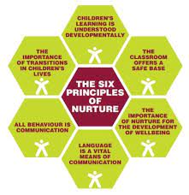

**“You** **can’t teach children to behave better by making them feel worse. When children feel better, they behave better.” - Pam Leo**

We take a non-judgemental, curious, and empathic attitude towards behaviour. We encourage all adults in school to respond in a way that focuses on the feelings and emotions that might drive certain behaviour, rather than the behaviour itself. Children displaying anti-social behaviours need to be regarded as vulnerable rather than troublesome, and we all have a duty to explore this vulnerability and provide appropriate support.

All behaviour is communication or a form of information. Children are not deliberately choosing to annoy, irritate or disrupt. Their feelings are driving everything they are doing. They are unable to rationalise that without being taught and supported to do so. It is our role to recognise that they are trying to tell us something and we need to help them regulate.

Language is a vital means of communication. At Bridgelea, we only use these terms:

* + Difficult/dangerous/unsocial or anti-social behaviour
  + A child is in crisis, dysregulated or distressed
  + A child is attention needing not attention seeking
  + A child has additional needs

# Developing trusting relationships with staff, children, and parents/carers

* + We have clear expectations that at the beginning of each school year the focus is **building positive relationships with all children** as these relationships are essential to support positive behaviour.
  + This is started through a transition program that gives children the opportunity to visit their new class and teacher before the summer holiday enabling children and staff to begin to get to know each other.
  + Children joining the school in September access transition visits prior to their start date.
  + The promotion of positive relationships continues every day at Bridgelea. Children at Bridgelea should feel safe, valued, respected, and liked by all adults. Adults show kindness, make connections, listen to children, and greet them when they see them.

# Praise and positive reinforcement – ‘catching children getting it right’

* + Positive praise - flooding the positive behaviour in every classroom, ‘catching the children getting it right,’ for following our rules and showing our values. Praise may be given publicly and privately and will vary depending on the needs of the child.
  + Positive facial expressions
  + Thumbs up
  + Displays recognising the effort children have put into learning
  + Personalised strategies to prevent predictable behaviour
  + Phone call home/at the classroom door
  + See another member of staff/class
  + Personalised compliments
  + If an adult at school needs to talk to a child about behaviours that are not prosocial this will be done privately to avoid humiliation or giving too much ‘airtime’ to anti-social behaviours.

# Responding as role models and using positive phrasing

* + Children learn best from being surrounded by good role models. Adults in school will always model consistent, calm adult behaviour.
  + We know that ‘children can’t be what they can’t see,’ therefore, all adults at school speak respectfully to each other, to children and about children.
  + We walk in the school building, listen to children when they talk to us and take time to teach children pro-social ways to behave, always linking this to our rules e.g., Thank you for holding the door open and showing respect.
  + We model to the children, often through talk, how we are feeling, how it is ok to have a wide range of feelings, and we show by example how being honest and talking through our experiences is a positive strategy.

# Consistency and consistent use of scripts.

* + By consistency we mean creating a culture and environment where children know that whichever adult they are talking to the **same expectations for behaviour are present and the way their behaviour is managed is the same.**
  + We achieve consistency by ensuring all staff are Team Teach trained every two years and in the interim a refresher is given. Staff also access Nurture and Restorative Approaches CPD annually.
  + Staff may have reminders of this policy through email, briefings, or staff meetings.
  + New staff are given this policy as part of their induction and this policy is reviewed by staff and governors annually.
  + We know that by having some agreed scripts that are positively phrased and used by all staff across school, children are more likely to feel secure that the expectations for their behaviour are the same. Some of these are “helps available”, “when and then”, “take a minute”, “let’s walk to safe base”, “kicking finished” for example.

# Routines, repetition, and structure with established clear and agreed boundaries/expectations

* + Having clear, predictable routines that all children are aware of will create a sense of feeling safe and prepared.
  + We use visual timetables for whole classes to share what the day is going to include.
  + Changes to a typical routine will be explained clearly to children. Social stories, communication with parents/carers, clear explanations, and now and next boards may be used with children.
  + To help children to feel safe, their educational environment needs to be high in both nurture and structure.

# Transitions are seen as important and managed carefully for all children

* + A nurturing approach encourages us to think about transitions in the widest context. Following holiday periods, between school years, moving class to class and even small transitions between activities in a classroom and from the playground to the classroom are all examples of transitions for young people.
  + When a young person has experienced adversity, changes (even between task and space) can trigger feelings of threat and hypervigilance.
  + We are mindful that changes in routine can be difficult for children and need to be carefully managed with preparation and support

# Comfort, forgiveness and restorative processes.

* + If children feel safe, happy, and respected they are more likely to display pro-social behaviours. They do not always get this right and it is vital that when they are struggling with this, they are given a fresh start. Every day is a new day. Adults need to forgive and model this forgiveness.
  + During difficult and dangerous behaviours, they need to encounter adults who are calm and consistent who respond in a predictable, consistent, empathetic way.
  + Children need to learn to forgive themselves and others and we are role models for this. When a child is displaying difficult or dangerous behaviours we remember this means they are not feeling safe or happy. We need to work out what the trigger is for this behaviour and try to de-escalate.
  + A child who has spent time in ‘crisis’ may need time to calm down before any educational consequence or conversation takes place, this may be the following day for some children.

This policy should be read in conjunction with other school policies:

* Anti-Bullying Policy
* Equality statement
* SEND Information Report
* Attendance Policy
* Feedback Policy
* Positive Handling Policy
* Safeguarding Policy
* Health and Safety Policy.

All policies are available on the school website for parents and on Parago for staff.

# Legislation and Statutory Requirements

This policy is based on advice from the Department for Education (DfE) on:

* [Behaviour in schools: advice for headteachers and school staff 2024](https://www.gov.uk/government/publications/behaviour-in-schools--2)
* [Searching, screening and confiscation: advice for schools 2022](https://www.gov.uk/government/publications/searching-screening-and-confiscation)
* [The Equality Act 2010](https://www.gov.uk/government/publications/equality-act-2010-advice-for-schools)
* [Keeping Children Safe in Education 2023](https://www.gov.uk/government/publications/keeping-children-safe-in-education--2)
* [Suspension and permanent exclusion from maintained schools, academies and pupil referral units in England, including pupil movement 2023](https://www.gov.uk/government/publications/school-exclusion)
* [Use of reasonable force in schools](https://www.gov.uk/government/publications/use-of-reasonable-force-in-schools)
* [Supporting pupils with medical conditions at school](https://www.gov.uk/government/publications/supporting-pupils-at-school-with-medical-conditions--3)
* [Special Educational Needs and Disability (SEND) Code of Practice](https://www.gov.uk/government/publications/send-code-of-practice-0-to-25)

In addition, this policy is based on:

* Section 175 of the [Education Act 2002](http://www.legislation.gov.uk/ukpga/2002/32/section/175), which outlines a school’s duty to safeguard and promote the welfare of its pupils
* Sections 88 to 94 of the [Education and Inspections Act 2006](http://www.legislation.gov.uk/ukpga/2006/40/section/88), which requires schools to regulate pupils’ behaviour and publish a behaviour policy and written statement of behaviour principles, and gives schools the authority to confiscate pupils’ property
* [DfE guidance](https://www.gov.uk/guidance/what-maintained-schools-must-publish-online#behaviour-policy) explaining that maintained schools must publish their behaviour policy online

# Definitions

**Misbehaviour** is defined as:

* Disruption in lessons, in corridors between lessons, and at break and lunchtimes
* Non-completion of classwork or homework
* Poor attitude
* Incorrect uniform

**Serious misbehaviour** is defined as:

* Repeated breaches of the school rules
* Any form of bullying
* Sexual violence, such as rape, assault by penetration, or sexual assault (intentional sexual touching without consent)
* Sexual harassment, meaning unwanted conduct of a sexual nature, such as:
* Sexual comments
* Sexual jokes or taunting
* Physical behaviour such as interfering with clothes
* Online sexual harassment, such as unwanted sexual comments and messages (including on social media), sharing of nude or semi-nude images and/or videos, or sharing of unwanted explicit content
* Vandalism
* Theft
* Fighting
* Smoking
* Racist, sexist, homophobic or discriminatory behaviour
* Possession of any prohibited/banned items. These are:
* Knives or weapons
* Alcohol
* Illegal drugs
* Stolen items
* Tobacco and cigarette papers
* E-cigarettes or vapes
* Fireworks
* Pornographic images
* Any article a staff member suspects has been, or is likely to be, used to commit an offence, or to cause personal injury to, or damage to the property of, any person (including the pupil)

**We have specific rules being enforced on the grounds of health, welfare, and safety. All children have the right to be safe.**

**Food and drink:** Other than packed lunches, no food of any kind should be brought into school (unless on medical grounds), including sweets, biscuits, and drinks.

Reasons: Sweets, etc. present obvious choking hazards. Food and crumbs left around school would soon create a hazardous and unhygienic environment. Many drinks can be of the high sugar, fizzy, high additive variety. This can have a detrimental effect on behaviour as well as on dental health. A choice of juice, milk or water is available during lunch.

Energy drinks such as Red Bull and Prime are not permitted in school.

**Jewellery:** Watches and stud earrings are the only items of jewellery which may be worn at school, and these must be removed during P.E (Physical Education). and swimming lessons. Staff are not to assist children with the removal of jewellery. If children cannot remove it themselves, it should be taken out at home on the days the child does PE (Physical Education). Any articles removed should be locked in the school office for the lesson.

Reasons: Rings, necklaces, bracelets etc. can turn a minor incident into a major accident if caught on apparatus or entangled in another child’s clothing or hair. Even stud earrings have the potential to cause severe tears to the wearer’s ears or injury to others.

**PE Kit** Appropriate clothing must be worn for all PE activities.

Indoors: -No jewellery, barefoot, shorts, tee-shirt or vest.

Reasons: It is dangerous to go on the apparatus wearing trainers or similar footwear because it is more difficult to feel. A combination of bare feet and trainers, etc. can result in trampled toes and damaged nails.

Outdoors: - No jewellery, plimsoles or trainers, shorts, tee shirt, tracksuit if preferred.

Reasons: Slip on shoes or laced shoes even with small heels are not suitable for games lessons. They provide insufficient grip, may cause injury to others if kicked off and often lead to twisted ankles.

**School Clothing:** The school has a separate school uniform policy. Parents are asked to send their children to school tidy and appropriately dressed for the day's weather. Only flat-heeled shoes should be worn. Football boots/studded boots are not permitted.

Reasons: The overwhelming majority of parents, staff and children expressed their preference for a school uniform. School uniform reinforces school identity and eliminates ‘brand’ fashion and stigma. High heel shoes and boots are unsafe for the school environment. All clothing should be named so if misplaced they can be given back to the correct child.

**Personal Property:** The school cannot accept responsibility for the loss or damage to clothing or personal property. Toys, games, and sports equipment must not be brought to school (except on special occasions when the teacher gives permission). Any money brought into school should be placed in an envelope and handed in to the office as soon as possible and never left in trays, bags, or coats.

Reasons: Suitable toys, games and sports equipment are provided for the playground and indoor play. Unsuitable equipment may present a risk to children and present the potential for theft or damage which can lead to conflict.

**Mobile Phones:** Mobile phones must be handed in to the school office upon arrival and collected at the end of the school day. They should never be left in trays or coats or used during school hours.

Reasons: During school hours contact is possible through the school’s land lines. Mobile phones are regarded as hazardous to health. They present an unacceptable disturbance to lessons, potential for theft and cyber bullying.

**Bullying:** Bullying is defined as the repetitive, intentional harming of 1 person or group by another person or group, where the relationship involves an imbalance of power.

Bullying is, therefore:

* Deliberately hurtful
* Repeated, often over a period
* Difficult to defend against

Bullying can include:

| TYPE OF BULLYING | DEFINITION |
| --- | --- |
| Emotional | Being unfriendly, excluding, tormenting |
| Physical | Hitting, kicking, pushing, taking another’s belongings, any use of violence |
| Prejudice-based and discriminatory, including:   * Racial * Faith-based * Gendered (sexist) * Homophobic/biphobic * Transphobic * Disability-based | Taunts, gestures, graffiti, or physical abuse focused on a particular characteristic (e.g., gender, race, sexuality) |
| Sexual | Explicit sexual remarks, display of sexual material, sexual gestures, unwanted physical attention, comments about sexual reputation or performance, or inappropriate touching |
| Direct or indirect verbal | Name-calling, sarcasm, spreading rumours, teasing |
| Cyber-bullying | Bullying that takes place online, such as through social networking sites, messaging apps or gaming sites |

Bridgelea has a separate [Anti Bullying Policy](https://www.bridgelea.manchester.sch.uk/page/policies/60499).

# Roles and Responsibilities

## The governing board

* Bridgelea management committee is responsible for reviewing and approving the written statement of behaviour principles.
* The Bridgelea management committee will also review the behaviour policy in conjunction with the headteacher and monitor the policy’s effectiveness, holding the headteacher to account for its implementation. This is completed termly throughout the year.

## The headteacher

* The headteacher is responsible for reviewing this behaviour policy in conjunction with the management committee, giving consideration to the school’s statement of behaviour principles. The headteacher will also approve this policy.
* The headteacher will ensure that the school environment encourages positive behaviour and that staff deal effectively with poor behaviour, and will monitor how staff implement this policy to ensure rewards and sanctions are applied consistently to all groups of pupils.
* The headteacher will ensure that this behaviour policy works alongside the other key policies to offer pupils both sanctions and support when necessary.
* The headteacher will ensure that the data from Iris is reviewed weekly to ensure that no groups of pupils are being disproportionately impacted by this policy.

## Staff

Staff are responsible for:

* Implementing the behaviour policy consistently.
* Modelling positive behaviour.
* Providing a personalised approach to the specific behavioural needs of pupils.
* Recording behaviour incidents promptly and accurately.
* The senior leadership team will support staff in responding to behaviour incidents where required.

## Parents

Parents are expected to:

* Support their child in adhering to the school charter.
* Inform the school of any changes in circumstances that may affect their child’s behaviour.
* Discuss any behavioural concerns with the class teacher and/or team promptly.

# Creating a Positive Ethos

At Bridgelea Primary School, creating a positive ethos is paramount to ensuring the success of all pupils. We continually develop and embed this ethos through several school systems:

* One Page Profiles and Communication Charts for all pupils which are reviewed and if necessary, updated each half term.
* [Boxall Profiles](https://www.nurtureuk.org/what-we-do/the-boxall-profile/) are completed termly.
* Skills for Life Passports are completed half termly with children
* Floor Charters are created at the beginning of each year and reviewed/ updated in the Spring and Summer terms. These enable classes to develop individual reward systems. They are monitored by class teams and the Nurture Leads for each floor / site.

|  |  |  |  |
| --- | --- | --- | --- |
| Whole School Nurture Lead | Nurture Lead Ground & Withington | Nurture Lead  Middle Floor | Nurture Lead  Top Floor |
|  |  |  |  |

* Nurturing activities, which consist of Boxall Profile target focused and developmental activities are permeated throughout the day. There is a focus on whole class strategies for Strand A and B, along with interventions and activities which target children’s individual needs. Where a child needs additional support, this is provided through Retreat Interventions.
* At Withington, certificates are given and at Longsight, raffle tickets are given to pupils for ensuring all rights are respected. This is celebrated on Friday each week.
* Interventions are delivered both in class and by the Retreat Team linked to specific behaviours around Harmful Sexualised Behaviour, name calling, transition, bereavement, bullying, social skills, and anger management. These include Kid Skills, Purr-Fect Skills, Nurturing Social and Emotional Development, The Anger Gremlin, The Anxiety Gremlin and CBT (Cognitive Behavioural Therapy).
* Staff also work with pupils to deliver peer massage, mindfulness, yoga, and strategies to promote socially acceptable behaviour including good manners.
* Parental/carer support is achieved through Class Dojo, School Spider, daily home school diaries, reviews, and phone calls, as necessary.

# The Role of Rewards and Celebration

* A child is less likely to display challenging behaviour if their needs are being met, and if their achievements are recognised and celebrated.
* Individual certificates may be awarded across school throughout the year, for example, when a child is able to complete a piece of written work, helps others access their rights in school or for achievements in swimming.
* Incentive stickers may also be given. Letters may be sent out to parents/ carers to praise a pupil when they have achieved well.
* Individual certificates including ‘Star of the Week’ and ‘I Followed our Charter,’ ‘I respected the rights of others’ are awarded at the end of each week in floor assembly.
* Good Work Assemblies are held by the Senior and Extended Leadership Teams throughout the school year, which gives pupils opportunities to share their achievements with the rest of the school.
* Most children respond to a positive approach where their efforts are acknowledged and make considerable efforts to improve their work and, when necessary, their behaviour.
* For children who find public praise uncomfortable, alternatives will be identified.
* There are also class and whole school celebrations throughout the year to which parents and carers are invited.

# Class Dojo / School Spider

* Class Dojo and School Spider (Daily Home/ School diaries as an alternative) are essential to maintaining consistency of response to behaviour and ensuring positive and rewarding experiences for the children in all contexts.
* Class Dojo is updated throughout the week by teaching staff and parents/carers also can comment or privately message a member of their child’s class team.
* Most children will respond to the Rights Respecting approach but regular verbal praise from a trusted significant adult at home is most important. Some parents prefer a phone call or a text message and this is discussed between the parent and the class teacher.

# Zones of Regulation

* At Bridgelea we understand that all children have difficulties recognising and regulating their emotions. Zones of Regulation is a programme to support children to build awareness of their feelings and develop a variety of strategies to support them to regulate.
* Zones of Regulation has 4 key “zones” that are linked to colours – red, green, yellow, and blue. Children explore that all zones are okay to experience but develop tools to support them to move to the green zone where they are happy and feel safe.
* This will promote children at Bridgelea to have improved mental wellbeing and esteem in social groups, helping them to realise their full potential. We hope that children will be equipped with strategies and tools so that their transitions to new classes or future schools will be positive and successful.
* Zones of Regulation is currently being implemented at Bridgelea with the hope that all classes are using this tool by the end of the Autumn term 2023.

# Logical Consequences

Both positive and negative consequences are used at Bridgelea to support the children’s’ understanding that all behaviours have a consequence for themselves and sometimes others.

These can be:

* Reward experiences that are personalised to the needs in your class.
* Verbal praise
* Stickers
* Raffle tickets
* Positive comment in book
* Certificate
* Phone call home
* Choice of activity
* Time with a friend
* Time with an adult
* Reward Trip
* Verbal reminder of rights respecting behaviour
* Loss of free time to catch up with work, tidy up etc
* Moving pupil to work alone
* Listen, Link, Learn conversation with appropriate member of staff
* Reflective conversation with member of SLT
* Social stories
* Specific teaching around emotions & strategies
* Retreat referral
* Comic strip narrative
* Use of Class Dojo

# Retreat

The Retreat Room is used as a positive means by which a pupil can withdraw or be withdrawn from the classroom or other area where he/ she is experiencing difficulties with a situation. The use of Retreat is monitored weekly to ensure positive impact for the children that are accessing this resource. The SENCO (Special Educational Needs Coordinator) and Extended Leadership Team will have regular updates to support development and effective use. Staff in The Retreat Room taught to respond to each pupil in relation to their developmental need and encourage a return to the learning space as soon as possible.

# Restorative Approaches

Restorative approaches are a fundamental element of building and repairing relationships. We understand that each child will need time to **reflect, repair, restore.** It is important that after an incident there is time to reflect, repair and restore. As soon as possible after an incident, if all parties are emotionally ready, it is essential to talk with a child to safeguard their emotional wellbeing and help them reflect and progress. The purpose of reflecting, repairing, and restoring is to re-visit the experience by re-telling and exploring the story with a changed set of feelings. During the incident, the child’s behaviour may be influenced by anger, frustration, disappointment etc. This will look different in each class and bespoke to the individual children. See examples below:

These questions can be used to guide the discussion.

* What happened?
* How were you thinking / feeling and how did it make others think and feel
* Who has been affected and how?
* What can we do to put things right? These then need to be done.
* What have we learnt and how can we respond differently next time

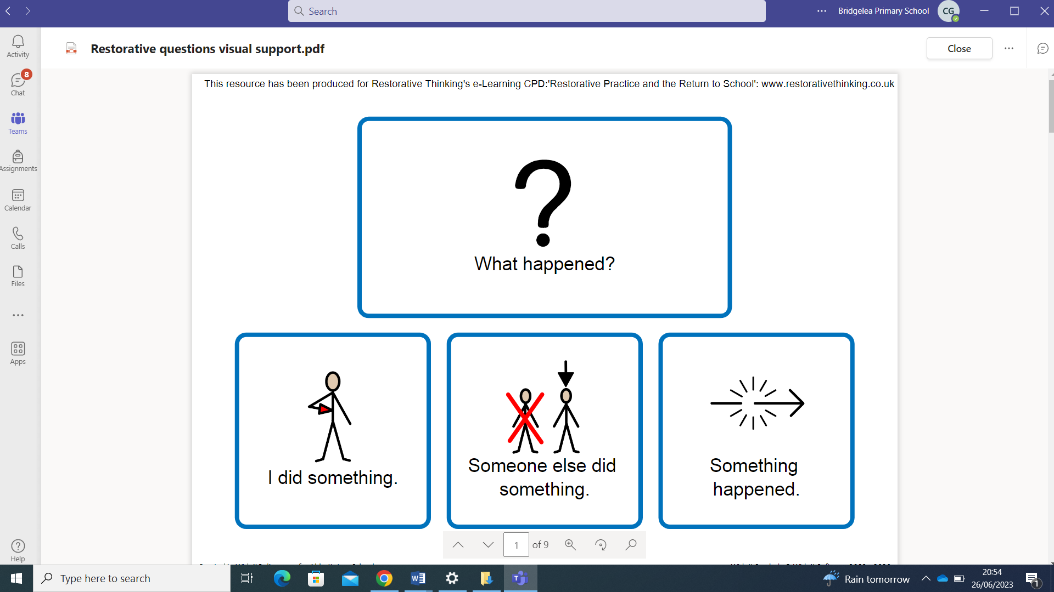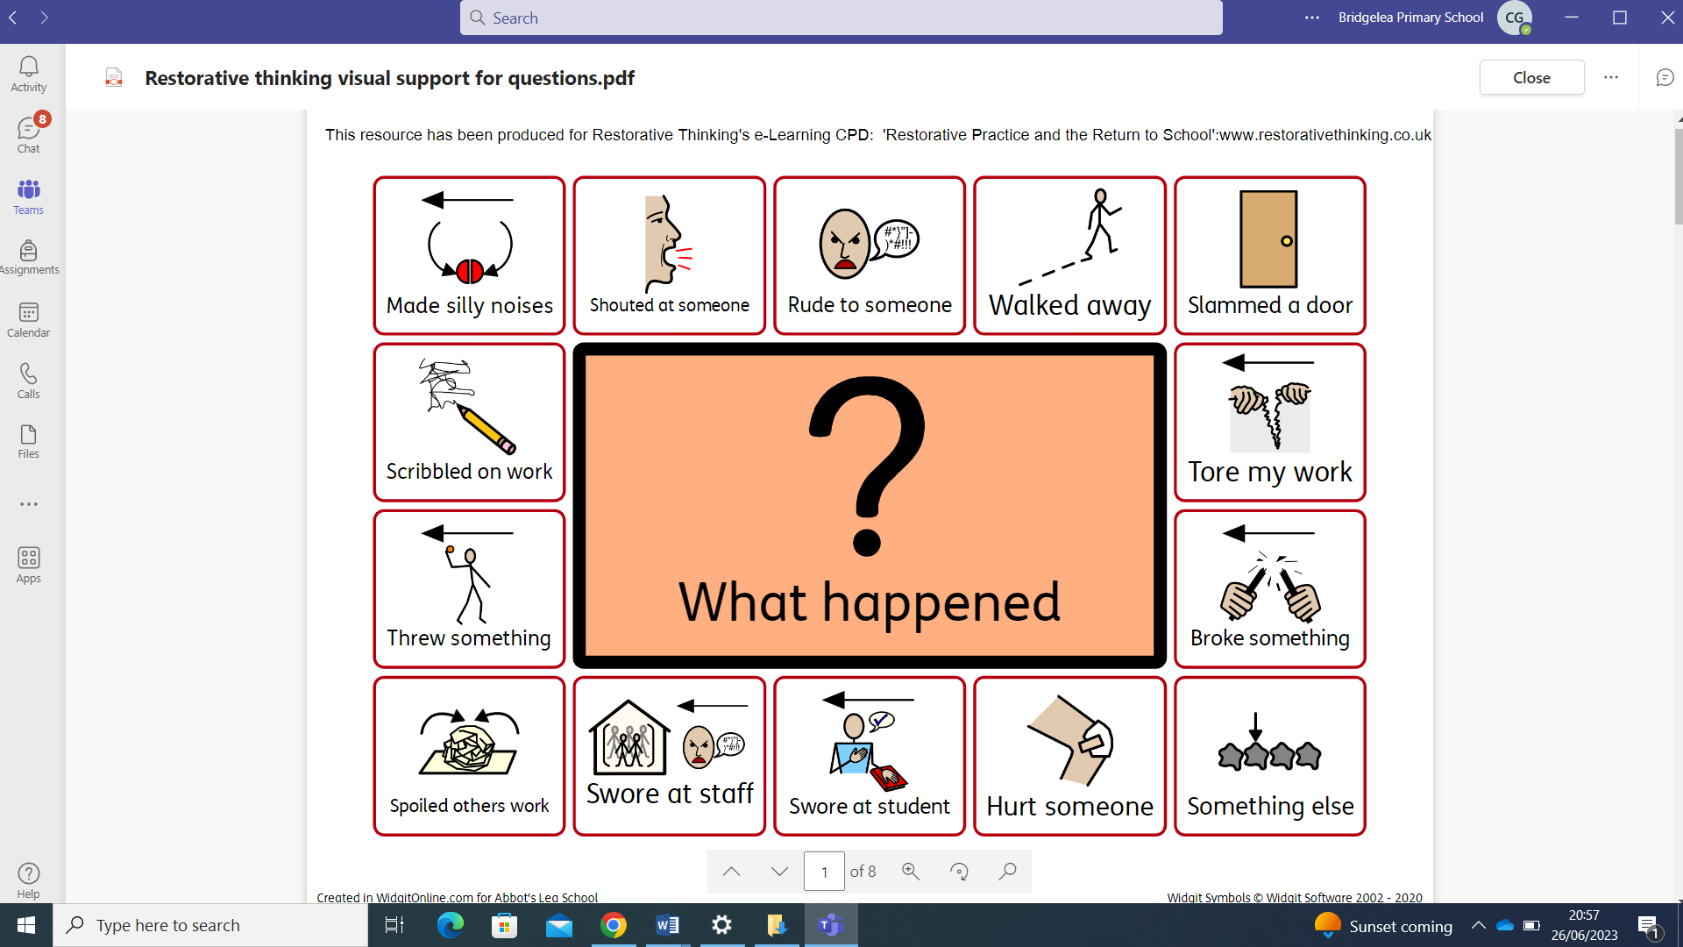

# Unsociable Behaviour

Unsocial behaviour is when a child is not enjoying or trying to behave sociably in the company of others, but not to the detriment of others. Not doing as instructed, but not to the detriment of others.

Examples:

* Leaving their desk without permission
* Leaving the carpet during input/story without permission
* Refusing to complete the work set
* Refusing to get changed for PE
* Choosing to do another activity than the one the class is doing (reading/drawing on whiteboard etc.)
* Rocking on their chair
* Calling out/talking to a friend
* Not listening to instructions
* Playing/fiddling with equipment

Staff should strive to interpret unsocial behaviour as a communication of negative feelings and so should provide differentiation or support.

Strategies that could be used:

* Differentiated learning space/workstation
* Fiddle toy
* Wobble cushion
* Whiteboard to write
* Timers
* Task plans
* Learning broken down
* Scaffolds
* Additional resources
* Individualised timetable
* Now and next board
* Limited choice
* Brain breaks
* Positive experience
* Class job
* Task differentiation
* Adult support/Peer support
* Learning intervention
* Small group/paired learning

# Antisocial Behaviour

Antisocial behaviour is behaviour that causes harm to an individual, a group, to the community or to the environment. Behaviour that is likely to cause injury, harassment, alarm, or distress. Behaviour that violates the rights of another person.

It is important not to group unsocial behaviour with antisocial behaviour. The child who can find no reason to join in or complete a directed task is often showing considerable restraint in not allowing how they feel to result in behaviours that are antisocial. It is important that our response to unsocial behaviour does not drive the behaviour to become antisocial.

|  |  |
| --- | --- |
| **Antisocial Behaviours** | **Dangerous Antisocial Behaviours** |
| Aggressive shouting/calling out disruptively | Leaving the school building |
| Continued interruptions | Leaving the premises |
| Swearing | Spitting (directly at another) |
| Answering back, mimicking | Scratching |
| Name calling | Pinching |
| Lying | Hair pulling |
| Refusal to carry out an adult’s request | Hitting |
| Distracting and/or disrupting others’ learning | Kicking |
| by shouting, banging, making noises | Fighting |
| Throwing small equipment | Biting |
| Leaving the classroom without permission | Punching |
| Damage to property/pushing over furniture | Throwing furniture |
| Stealing | Physical or verbal bullying |

These behaviours will be a sign of a child needing support and a child may be in a heightened, anxious state – due to factors outside of school – please be aware and empathetic of this and that their behaviour is communicating a need.

If a child is not managing to display pro-social behaviours, we need to teach the behaviour we want to see.

* + It could be a ‘**quick catch up’**
  + It could be **reflected, repair and restore**
  + It could be a **logical consequence** (clearing up a mess, mending something)
  + You may need to **teach something, practice something**,

**Examples of protective and educational consequences**

|  |  |
| --- | --- |
| **Antisocial Behaviours** | **Educational Consequence/Protective Consequence** |
| Aggressive shouting/calling out disruptively Continued interruptions | Social story  Comic strip conversation  Conversation and exploration using restorative approaches  Rehearsing and practising  Differentiated learning space |
| Swearing  Answering back, mimicking | Conversation and exploration Comic strip conversation Additional strategies provided |
| Name calling | Conversation and exploration Comic strip conversations  Teaching about empathy  Restorative conversations |
| Refusal to carry out an adult’s request Distracting and/or disrupting others’ learning by shouting, banging, making noises Throwing small equipment | Conversation and explorations Comic strip conversation  Additional strategies provided  School rules project – what is kindness and respect |
| Damage to property/pushing over furniture | Assist in repairs  Potential payment for damage/replacement |
| Stealing | Research the real-world implications |
| Physical or verbal bullying Physical aggression | Impact to those effected through a comic strip conversation  Restorative conversations – reflect, repair, restore  Limit to outside space Escorted in social situations/breaktimes  Restricted off-site activities Differentiated teaching space |

# Safeguarding

The school recognises that changes in behaviour may be an indicator that a pupil needs help or protection.

We will consider whether a pupil’s misbehaviour may be linked to them suffering, or being likely to suffer, significant harm.

Where this may be the case, we will follow our child protection and safeguarding policy, and consider whether pastoral support, an early help intervention or a referral to children’s social care is appropriate.

Please refer to our child protection and safeguarding policy for more information.

# Responding to misbehaviour

When a pupil’s behaviour falls below the standard that can be expected of them, staff will respond to restore a calm and safe learning environment, and to prevent recurrence of misbehaviour.

Staff will endeavour to create a predictable environment by always challenging behaviour that falls short of the standards, and by responding in a consistent, fair, and proportionate manner, so pupils know with certainty that misbehaviour will always be addressed.

De-escalation techniques, including the use of pre-arranged scripts and phrases, can be used to help prevent further behaviour issues arising.

All pupils will be treated equitably under the policy, with any factors that contributed to the behavioural incident identified and considered.

When giving behaviour sanctions, staff will also consider what support could be offered to a pupil to help them to meet behaviour standards in the future.

The school may use 1 or more of the following sanctions in response to unacceptable behaviour:

* A verbal reprimand and reminder of the expectations of behaviour
* Sending the pupil out of the class to access support in Retreat or a safe space on the corridor.
* Expecting work to be completed at home, or at break or lunchtime
* Referring the pupil to a senior member of staff
* Letter or phone call home to parents/carers
* Agreeing a behaviour contract
* Removal of the pupil from the classroom (Internal Suspension)
* Suspension
* Permanent exclusion, in the most serious of circumstances

Personal circumstances of the pupil will be considered when choosing sanctions, and decisions will be made on a case-by-case basis, but with regard to the impact on perceived fairness.

# Reasonable force

Reasonable force covers a range of interventions that involve physical contact with pupils. All members of staff have a duty to use reasonable force, in the following circumstances, to prevent a pupil from:

* Causing disorder (Serious disruption of learning)
* Hurting themselves or others
* Damaging property
* Committing an offence

Incidents of reasonable force must:

* Always be used as a last resort
* Be applied using the minimum amount of force and for the minimum amount of time possible
* Be used in a way that maintains the safety and dignity of all concerned
* Never be used as a form of punishment
* Be recorded and reported to parents/carers promptly

When considering using reasonable force, staff should, in considering the risks, carefully recognise any specific vulnerabilities of the pupil, including SEND, mental health needs or medical conditions.

# Searching, screening and confiscation

Searching, screening and confiscation is conducted in line with the DfE’s [latest guidance on searching, screening and confiscation](https://www.gov.uk/government/publications/searching-screening-and-confiscation).

## Confiscation

Any prohibited items (listed in section 3) found in a pupil’s possession as a result of a search will be confiscated. These items will not be returned to the pupil.

We will also confiscate any item that is harmful or detrimental to school discipline. These items will be returned to pupils after discussion with senior leaders and parents/carers, if appropriate.

## Searching a pupil

Searches will only be carried out by a member of staff who has been authorised to do so by the headteacher, or by the headteacher themselves.

Subject to the exception below, the authorised member of staff carrying out the search will be of the same sex as the pupil, and there will be another member of staff present as a witness to the search.

An authorised member of staff of a different sex to the pupil can carry out a search without another member of staff as a witness if:

* The authorised member of staff carrying out the search believes there is risk that serious harm will be caused to a person if the search is not carried out as a matter of urgency; **and**
* In the time available, it is not reasonably practicable for the search to be carried out by a member of staff who is the same sex as the pupil; **or**
* It is not reasonably practicable for the search to be carried out in the presence of another member of staff

When an authorised member of staff conducts a search without a witness, they should immediately report this to another member of staff, and make sure a written record of the search is kept.

If the authorised member of staff considers a search to be necessary, but not required urgently, they will seek the advice of the headteacher, designated safeguarding lead (or deputy) or pastoral member of staff who may have more information about the pupil. During this time, the pupil will be supervised and kept away from other pupils.

A search can be carried out if the authorised member of staff has reasonable grounds for suspecting that the pupil is in possession of a prohibited item or any item identified in the school rules for which a search can be made, or if the pupil has agreed.

An appropriate location for the search will be found. Where possible, this will be away from other pupils. The search will only take place on the school premises or where the member of staff has lawful control or charge of the pupil, for example on a school trip.

Before carrying out a search the authorised member of staff will:

* Assess whether there is an urgent need for a search
* Assess whether not doing the search would put other pupils or staff at risk
* Consider whether the search would pose a safeguarding risk to the pupil
* Explain to the pupil why they are being searched
* Explain to the pupil what a search entails – e.g. “I will ask you to turn out your pockets and remove your scarf”
* Explain how and where the search will be carried out
* Give the pupil the opportunity to ask questions
* Seek the pupil’s co-operation

If the pupil refuses to agree to a search, the member of staff can give an appropriate behaviour sanction.

If they still refuse to co-operate, the member of staff will contact the headteacher / designated safeguarding lead or deputy head, to try to determine why the pupil is refusing to comply.

The authorised member of staff will then decide whether to use reasonable force to search the pupil. This decision will be made on a case-by-case basis, taking into consideration whether conducting the search will prevent the pupil harming themselves or others, damaging property or causing disorder.

The authorised member of staff can use reasonable force to search for any prohibited items identified in section 3, but not to search for items that are only identified in the school rules.

The authorised member of staff may use a metal detector to assist with the search.

An authorised member of staff may search a pupil’s outer clothing, pockets, possessions, desk, or locker.

‘Outer clothing’ includes:

* Any item of clothing that is not worn next to the skin or immediately over underwear (e.g. a jumper or jacket being worn over a t-shirt)
* Hats, scarves, gloves, shoes, or boots

## Searching pupils’ possessions

Possessions means any items that the pupil has or appears to have control of, including:

* Desks
* Lockers
* Bags

A pupil’s possessions can be searched for any item if the pupil agrees to the search. If the pupil does not agree to the search, staff can still carry out a search for prohibited items (listed in section 3) and items identified in the school rules.

An authorised member of staff can search a pupil’s possessions when the pupil and another member of staff are present.

If there is a serious risk of harm if the search is not conducted immediately, or it is not reasonably practicable to summon another member of staff, the search can be carried out by a single authorised member of staff.

## Informing the designated safeguarding lead (DSL)

The staff member who carried out the search should inform the DSL without delay, and this must be recorded on CPoms:

* Of any incidents where the member of staff had reasonable grounds to suspect a pupil was in possession of a prohibited item as listed in section 3
* If they believe that a search has revealed a safeguarding risk

All searches for prohibited items (listed in section 3), including incidents where no items were found, will be recorded in the school’s safeguarding system.

## Informing parents/carers

Parents/carers will always be informed of any search for a prohibited item (listed in section 3). A member of staff will tell the parents/carers as soon as is reasonably practicable:

* What happened
* What was found, if anything
* What has been confiscated, if anything
* What action the school has taken, including any sanctions that have been applied to their child

## Support after a search

Irrespective of whether any items are found as the result of any search, the school will consider whether the pupil may be suffering or likely to suffer harm and whether any specific support is needed (due to the reasons for the search, the search itself, or the outcome of the search).

If this is the case, staff will follow the school’s safeguarding policy and speak to the designated safeguarding lead (DSL). The DSL will consider whether pastoral support, an early help intervention or a referral to children’s social care is appropriate.

## Strip searches

The authorised member of staff’s power to search outlined above does not enable them to conduct a strip search (removing more than the outer clothing) and strip searches on school premises shall only be carried out by police officers in accordance with the [Police and Criminal Evidence Act 1984 (PACE) Code C.](https://www.gov.uk/government/publications/pace-code-c-2019)

Before calling the police into school, staff will assess and balance the risk of a potential strip search on the pupil’s mental and physical wellbeing and the risk of not recovering the suspected item.

Staff will consider whether introducing the potential for a strip search through police involvement is absolutely necessary, and will always ensure that other appropriate, less invasive approaches have been exhausted first.

Once the police are on school premises, the decision on whether to conduct a strip search lies solely with them. The school will advocate for the safety and wellbeing of the pupil(s) involved. Staff retain a duty of care to the pupil involved and should always advocate for pupil wellbeing.

## Communication and record-keeping

Where reasonably possible and unless there is an immediate risk of harm, before the strip search takes place, staff will contact at least 1 of the pupil’s parents/carers to inform them that the police are going to strip search the pupil, and ask them whether they would like to come into school to act as the pupil’s appropriate adult. If the school cannot contact the parents/carers, or they are not able to come into school to act as the appropriate adult, a member of staff can act as the appropriate adult (see below for information about the role of the appropriate adult).

The pupil’s parents/carers will always be informed by a staff member once a strip search has taken place. The school will keep records of strip searches that have been conducted on school premises and monitor them for any trends that emerge.

# Screening

At Bridgelea children are not routinely screened. If we feel that the risk of a child bringing a prohibited item into school has increased we will contact the parent and wider agencies and discuss how the child will be screened for this item to reduce risk of harm to self and others. This will be recorded on a child’s risk assessment and agreed with parents.

# Off-site misbehaviour

Sanctions may be applied where a pupil has misbehaved off-site when representing the school. This means misbehaviour when the pupil is:

* Taking part in any school-organised or school-related activity (e.g. school trips)
* Travelling to or from school
* Wearing school uniform
* In any other way identifiable as a pupil of our school

Sanctions may also be applied where a pupil has misbehaved off-site, at any time, whether the conditions above apply, if the misbehaviour:

* Could have repercussions for the orderly running of the school
* Poses a threat to another pupil
* Could adversely affect the reputation of the school

Sanctions will only be given out on school premises or elsewhere when the pupil is under the lawful control of a staff member (e.g. on a school-organised trip).

# Online misbehaviour

The school can issue behaviour sanctions to pupils for online misbehaviour when:

* It poses a threat or causes harm to another pupil
* It could have repercussions for the orderly running of the school
* It adversely affects the reputation of the school
* The pupil is identifiable as a member of the school

Sanctions will only be given out on school premises or elsewhere when the pupil is under the lawful control of a staff member.

# Suspected criminal behaviour

If a pupil is suspected of criminal behaviour, the school will make an initial assessment of whether to report the incident to the police.

When establishing the facts, the school will endeavour to preserve any relevant evidence to hand over to the police.

If a decision is made to report the matter to the police, a member of the senior leadership team will make the report.

The school will not interfere with any police action taken. However, the school may continue to follow its own investigation procedure and enforce sanctions, if it does not conflict with police action.

If a report to the police is made, the designated safeguarding lead (DSL) will make a tandem report to children’s social care, if appropriate.

# Zero-tolerance approach to sexual harassment and sexual violence

The school will ensure that all incidents of sexual harassment and/or violence are met with a suitable response, and never ignored.

Pupils are encouraged to report anything that makes them uncomfortable, no matter how ‘small’ they feel it might be.

The school’s response will be:

* Proportionate
* Considered
* Supportive
* Decided on a case-by-case basis

The school has procedures in place to respond to any allegations or concerns regarding a child’s safety or wellbeing. These include clear processes for:

* Responding to a report
* Carrying out risk assessments, where appropriate, to help determine whether to:
  + Manage the incident internally
  + Refer to early help
  + Refer to children’s social care
  + Report to the police

Please refer to our child protection and safeguarding policy for more information

# Malicious allegations

Where a pupil makes an allegation against a member of staff and that allegation is shown to have been deliberately invented or malicious, the school will consider whether to discipline the pupil in accordance with this policy.

Where a pupil makes an allegation of sexual violence or sexual harassment against another pupil and that allegation is shown to have been deliberately invented or malicious, the school will consider whether to discipline the pupil in accordance with this policy.

In all cases where an allegation is determined to be unsubstantiated, unfounded, false, or malicious, the school (in collaboration with the local authority designated officer (LADO), where relevant) will consider whether the pupil who made the allegation needs help, or the allegation may have been a cry for help. If so, a referral to children’s social care may be appropriate.

The school will also consider the pastoral needs of staff and pupils accused of misconduct.

Please refer to our child protection and safeguarding policy. We also have an Allegations Against Staff Policy for more information on responding to allegations of abuse against staff or other pupils.

# Removal from classrooms

In response to serious or persistent breaches of this policy, the school may remove the pupil from the classroom for a limited time.

Pupils who have been removed will continue to receive education under the supervision of a member of staff. This education will be meaningful, but it may differ from the mainstream curriculum.

Removal is a serious sanction and will only be used in response to serious misbehaviour. Staff will only remove pupils from the classroom once other behavioural strategies have been attempted, unless the behaviour is so extreme as to warrant immediate removal.

Removal can be used to:

* Restore order if the pupil is being unreasonably disruptive
* Maintain the safety of all pupils
* Allow the disruptive pupil to continue their learning in a managed environment
* Allow the disruptive pupil to regain calm in a safe space

Pupils who have been removed from the classroom are supervised by Bridgelea staff and will be supported to return to the classroom as soon as it is safe to do so.

Pupils will not be removed from classrooms for prolonged periods of time without the explicit agreement of the headteacher and as a part of a child’s transition plan, reintegration plan, internal suspension, or Communication Chart.

Pupils should be reintegrated into the classroom as soon as it is appropriate and safe to do so. The school will consider what support is needed to help a pupil successfully reintegrate into the classroom and meet the expected standards of behaviour.

Parents/carers will be informed on the same day that their child is removed from the classroom.

The school will consider an alternative approach to behaviour management for pupils who are frequently removed from class, such as:

* Retreat referral
* Use of teaching assistants
* Multi-agency assessment

# Suspension and permanent exclusion

The school can use suspension and permanent exclusion in response to serious incidents or in response to persistent poor behaviour which has not improved following in-school sanctions and interventions.

The decision to suspend or exclude will be made by the headteacher and only as a last resort.

Please refer to our exclusions policy for more information.

# Levels of Response:

## Level 1

At Bridgelea we believe that all behaviour is communication. Children are supported by adults throughout the school day. At times, a pupil may show signs of dysregulation. At this point, adults complete a dynamic risk assessment to assess where the arousal cycle the child is and use emotion coaching strategies to help pupils to identify their emotions and the underlying cause of these.

This is supported in the classroom through Quality First Teaching (QFT) and a range of de-escalation/distraction strategies that staff have developed alongside the children. This is captured on the One Page Profiles and Communication Charts.

At Bridgelea, staff members are trained in the use of help scripts and emotion coaching. This helps to identify children’s triggers and as a tool to prevent children from escalating on the arousal curve. Help scripts may be: “I can see something has happened, I’m here to help; You talk and I’ll listen; I wonder if you are feeling.... because....”

When children are making the right choices, rights respecting language is used at this time;

* You were really respecting her right to…
* Were you respecting his right to…
* Respect each other’s right to…
* How do we respect…

Reflection through restorative approaches is completed verbally within class to encourage the use of the emotional language to express feelings. Children are supporting through Zones of Regulation to develop strategies to manage their emotions. This is regularly reinforced throughout paperwork and scripts within the day. Children have explicit sessions to teach them about emotions and develop their emotional regulation skills in addition to reflecting on incidents.

## Level 2

If the pupil is showing signs of escalating behaviour, they will need 1-1 support. Adults will use strategies to de-escalate the situation. All pupils have a Communication Chart, which is written with the pupil to identify strategies for support at these times. Inline with our Elklan practice adults will be cautious to avoid using lengthy discussions at this point.

The safe base chairs or safe base might be used at this time. Children will be encouraged to self-soothe and then return quickly to the learning space. Children will be rewarded when back on task. If children are unable to self-soothe staff may direct children to Safe Base or Retreat Room initially with clear rewards for a quick return. Staff may support children to Retreat with reassuring touch or a guide if necessary.

Post incident learning is completed using a ‘Listen, Link, Learn’ conversation and the emotional scale to express feelings and support the use of different choices next time or an alternative appropriate strategy.

## Level 3

Children who begin to display behaviours that show increased risk to themselves, others or property, may need support to regain control. Staff are encouraged to continue with Level 1 and 2 strategies whilst being mindful that physical intervention may be necessary. (See the Physical Intervention Policy)

Any physical intervention will be used for minimal time and where possible, will be away from other pupils. At this time, adults will provide reassurance to the pupil but will avoid reprimanding or attempting to discuss behaviour at this point.

In some cases, adults will need to seek support from a member of the Senior Leadership Team (SLT).

Such situations may involve:

* **significant and repeated** verbal or significant physical abuse of pupils or staff
* deliberate and **significant** damage to property
* concerns about the **risk** to other pupils nearby
* **frequent** and **intentional** use of foul language (racial abuse/homophobic language
* **repeated and/or prolonged** physical intervention

Safe base rooms and corridors are available to pupils to support children to regulate.

# Post Incident Learning

Post incident learning through restorative practice is a fundamental part of our ethos. After all need for restrictive physical intervention, children will access post incident learning. This may look different in each class and for each pupil and is personalised for the child. For all children, we aim for a high challenge, high support environment to promote independence and resilience in cognitive and social emotional development. At Bridgelea we understand people so we acknowledge that people involved will have their own unique perspectives. Staff encourage a restorative dialogue to help resolve difficult situations. At Bridgelea we understand that children need the opportunity to “listen, link and learn” after incidents, when they are ready, with a safe and trusted adult.

Listen – “What happened?”

Link – “How did that make you feel?”

Learn – “What can you do differently the next time that you feel that way?”

Restorative questions used to support reflection and resolution include:

* What happened?
* What were you thinking?
* How did you feel?
* How are you now?
* What can you do next time you feel….?
* Who else has been affected?
* What do you need to feel better?
* What should happen to put things right?
* This can be presented using visuals to help children and personalised to the needs of the children.

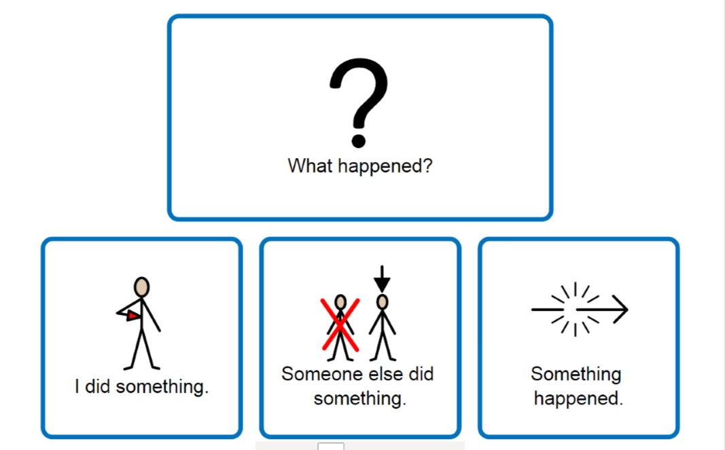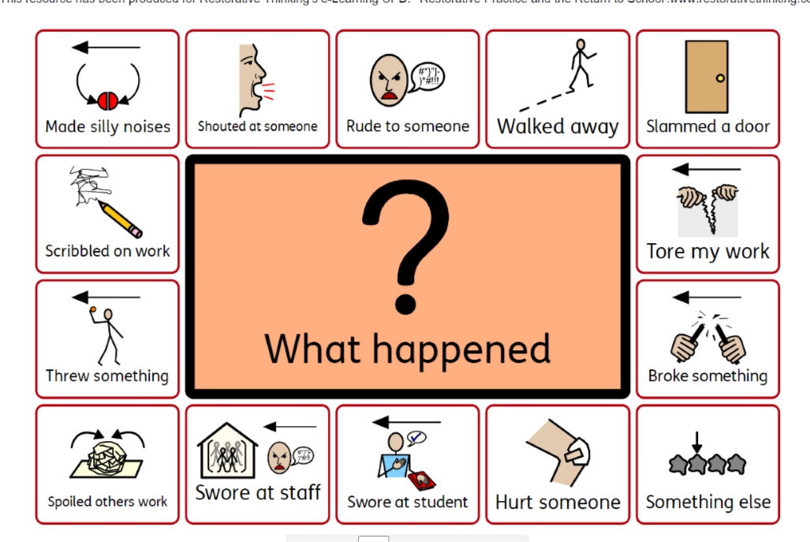

# Serious Incidents and Logical Consequences

Repeated episodes or a single severe incident of the following behaviours:

* Absconding from the school site
* Unprovoked assaults on members of staff or pupils
* Serious disruption of the learning environment

These may lead to the child working in internal exclusion away from the other children, sometimes including lunch and breaks, to acknowledge the seriousness of the incident and demonstrate that the rights and feelings of other children and staff are recognised. Reasonable adjustments can be made so that support can be put in place for the child to return to class e.g. holding a solution circle as part of the graduated response. Should the child need additional support to return to class, this will be supported through discussion with the SENCO and members of SLT.

Should an incident result in a fixed term suspension by the Headteacher, then a Reintegration plan will be written or reviewed.

The fixed term suspension will be used by the team and SLT to write and/ or review the Reintegration Plan. This will ensure that reasonable adjustments are made and systems are in place for when the child returns.

Before returning to school a reintegration meeting will be held with a member of the SLT, parent/ carer, child and a member of the class team in order to discuss the incident and to share the plan. At this meeting the Reintegration Plan will be agreed and a possible phased return to class may be agreed.

If after further investigation and the implementation of different strategies the child’s behaviour remains a considerable risk to staff or children within the school a review of the Communication Chart and Reintegration Plan will be made. The Headteacher may make provision for a one to one tuition, possibly at another part of the Bridgelea provision or at home whichever is deemed most appropriate.

Where a reintegration meeting cannot be arranged, this will not be a barrier to the child returning to school from a fixed term suspension (and adjustments will be put in place within school as appropriate).

# Reduced Timetables

All children, regardless of their circumstances, are entitled to a full-time education which is suitable to their age, ability, aptitude and any special educational needs they may have and schools have a statutory duty to provide full-time education for all pupils. It is unlawful for a school to impose a reduced or part-time timetable and any reduced timetable may only be used as a short-term measure towards achieving full time integration with the consent of parents/carers.

‘All pupils of compulsory school age are entitled to a full-time education. In very exceptional circumstances there may be a need for a temporary part-time timetable to meet a pupil’s individual needs. For example, where a medical condition prevents a pupil from attending full-time education and a part-time timetable is considered as part of a re-integration package. A part-time timetable must not be treated as a long-term solution. Any pastoral support programme or other agreement must have a time limit by which point the pupil is expected to attend full-time or be provided with alternative provision.

In agreeing to a part-time timetable, a school has agreed to a pupil being absent from school for part of the week or day and therefore must record it as authorised absence’.

School attendance: Guidance for maintained schools, academies, independent schools and local authorities, DfE, July 2019

## Circumstances where it might be considered

A part-time/personalised timetable may be considered for a short time. Below are some real examples, but the list is not exhaustive.

* Where a student has not been in a formal education setting previously and may require a staged induction. An example of this is a student arriving from another country.
* Where a student has been educated other than at school – often home educated for a substantial amount of time – and joins the roll of a school and a staged induction is deemed beneficial.
* Students with a prolonged absence due to a physical or mental health condition where recovery demands a slower build up to full-time education.
* Students recovering from a temporary health issue that is not long term.

# Safeguarding

Schools have a safeguarding responsibility for all pupils on their roll and therefore must be aware that even with parent/carer agreement to any reduced timetable arrangement they make, they are responsible for the safeguarding and welfare of pupils on roll who are off-site during school hours. If evidence suggests that the child will be exposed to significant risk if not in school, then a reduced timetable should not be considered an option.

The expectation is that schools will have:

* previously put in relevant interventions to engage the child in education
* referred to Early Help or to the District Advice & Guidance Team if they have serious concerns about a child
* completed a risk assessment before meeting with the parents to discuss.

# Absconding

If a child leaves the building they are to be followed but only to the boundary of the school premises. The pupil is to be reminded, if appropriate, that if they leave the school site and go out of staff sight the police and their parents/ carers will be informed. Staff must continue to observe/ support as long as the pupil is in sight, perhaps moving back towards the building if the pupil begins to return.

If the pupil does go out of sight a phone call is to be made to parents/ carers and the police.

If the pupil is younger and/ or of higher risk as noted on their Communication Chart, a member of staff may follow after taking a school mobile and informing the senior member of staff on site. Bridgelea staff remain responsible for the safeguarding of the child and will use a dynamic risk assessment to best meet the needs of the child until the child is safe back on premises or handed over to carer. Where a child is a known risk of absconding, staff will complete an absconding risk assessment.

**Communicating with Parents**

We work closely with parents to enable them to engage with school to support their child, as we know that successful joint working between the home and school leads to much better outcomes for our children. Through protective and educational consequences, we aim to teach children to manage their own feelings and learn from their mistakes. It is our aim that they will develop strategies to enable them to self-regulate. Parents will be informed of concerns early on by the class teacher and incidents of unsocial or antisocial behaviours will be communicated to parents. We ask families to openly communicate behaviours or events from home so that we can offer support to their child in the most informed and effective way.

When progress is limited, we ensure parents continue to be informed and included through review meetings, led by the SENCO or another member of the senior leadership team, to monitor and track progress. These are an opportunity to share positives about a child, areas that need improvement and strategies in place to support. This may be just a meeting to track progress or include a risk reduction management plan or pastoral support plan. We expect parents to attend these. We support remote meeting where required.

# A Reintegration Plan

The reintegration plan is in place for children at risk of exclusion. This will be closely monitored over a set period. Further intervention will be in place which could include a reduced timetable. A significant change needs to be seen in a child’s behaviour to avoid exclusion.

# A Safety and Support Plan

A ‘Safety and Support Plan’ or ‘Risk Assessment Management Plan’ (RAMP) may be required when an incident of sexual harassment or sexual violence has occurred. This is to identify risks for the victim, perpetrator and other children and so that all staff are aware of their duty of care to the children. Typically, these plans will include specific forms of intervention to maintain a pupil’s own safety and that of others.

# Sexual Harrassment and/or Violence

The school will ensure that all incidents of sexual harassment and/or violence are met with a suitable response, and never ignored. Pupils are encouraged to report anything that makes them uncomfortable, no matter how ‘small’ they feel it might be.

The school’s response will be:

* Proportionate
* Considered
* Supportive
* Decided on a case-by-case basis

The school has procedures in place to respond to any allegations or concerns regarding a child’s safety or wellbeing. These include clear processes for:

* Responding to a report
* Carrying out risk assessments, where appropriate, to help determine whether to:
* Manage the incident internally
* Refer to early help
* Refer to children’s social care
* Report to the police

Please refer to our safeguarding policy for more information.

# Malicious Allegations

Where a pupil makes an allegation against a member of staff and that allegation is shown to have been deliberately invented or malicious, the school will follow this up with the pupil and their family/carer in accordance with this policy.

Where a pupil makes an allegation of sexual violence or sexual harassment against another pupil and that allegation is shown to have been deliberately invented or malicious, the school will follow this up with the pupil and their family/carer in accordance with this policy.

In all cases where an allegation is determined to be unsubstantiated, unfounded, false or malicious, the school (in collaboration with the local authority designated officer, where relevant) will consider whether the pupil who made the allegation is in need of help, or the allegation may have been a cry for help. If so, a referral to children’s social care may be appropriate.

The school will also consider the pastoral needs of staff and pupils accused of misconduct.

Please refer to our safeguarding policy for more information on responding to allegations of abuse against staff or other pupils.

# Confiscation

**Any prohibited items found in pupils’ possession will be confiscated.** These items will not be returned to pupils. We will also confiscate any item which is harmful or detrimental to school discipline and safety. These items will be returned to pupils or their family/carers after discussion with senior leaders and parents, if appropriate.

Searching and screening pupils is conducted in line with the DfE’s [latest guidance on searching, screening and confiscation](https://www.gov.uk/government/publications/searching-screening-and-confiscation).

# Child Protection

It must be noted that the above stages will be adapted if it is felt that child protection issues are involved and a full consideration of implications will be made. The school safeguarding policy will be followed at all times. If social care are involved and adjustments are made to children’s timetables or access to school, social workers will be informed.

# Monitoring arrangements

This behaviour policy will be reviewed by the headteacher and management committee at least annually, or more frequently, if needed, to address findings from the regular monitoring of the behaviour records. At each review, the policy will be approved by the management committee.

The written statement of behaviour principles (appendix 1) will be reviewed and approved by the management committee annually.

# Governor Consultation

All governors have been consulted in the development of this policy and their comments taken into account. The policy has been duly ratified in line with statutory procedures.

# Parental Consultation

Parents have been consulted and they are informed of the policy and its practical implications for pupils. Their comments have been taken into account and the full policy is held in school and is made available to them on request.

# Staff Consultation

All staff have been consulted in the development of this policy and their comments taken into account. This took place in the Summer term annually.

# Appendix 1: Written Statement of Behaviour Principles

The Education and Inspections Act 2006 requires Governors to make, and from time to time review, a written statement of general principles to guide the Headteacher in determining measures to promote good behaviour.

Our overall vision of '**Understanding People**' captures our core purpose perfectly. At Bridgelea school we want to help our children, families, and communities to understand themselves and others more, whilst developing their understanding of the statutory and wider curriculum. Additionally, staff work closely with pupils and their parents and carers to develop pupils’ overall social and emotional capacity. Unacceptable behaviour is always challenged in an appropriate and systematic way.

Our relationships are underpinned by the Rights Respecting principles of equality, mutual respect, fairness and consistency and the nurturing principles linked to communication, transition, wellbeing and creating a safe base. We have high expectations that support the development of young people as effective and responsible citizens.

The purpose of the behaviour and relationships policy is to encourage the best possible behaviour from all of our children and adults and we endeavour to work alongside pupils and parents/carers to plan individual approaches to maintain positive conduct.

Our priority is to encourage socially appropriate behaviour from and for all:

* Every pupil has the right to feel safe, valued and respected and able to learn free from the disruption of others
* All pupils, staff and visitors are free from any form of discrimination
* Staff and volunteers set an excellent example to pupils at all times
* Rewards, consequences and reasonable force are used consistently by staff, in line with the behaviour and physical intervention policy
* The Behaviour and Relationships Policy is understood by all pupils and staff
* Pupils are helped to understand the result their action has on the rights of others
* Families are involved in behaviour and relationship discussions to foster good relationships between the school and pupils’ home life through Class Dojo, parent craft / café mornings, phone calls and where necessary more intense planned support.

# Appendix 2 Graduated Response



# Appendix 3

**Nurture, Rights Respecting and Trauma Informed Practice permeates our curriculum, ethos and values. This following illustrates examples of how we implement this at Bridgelea.**

**How do we implement our Behaviour, Communication and Relationships Policy at Bridgelea?**

**Protect**:

At Bridgelea, we build a foundation on a nurturing, highly structured and predictable school community. Pupil timetables/ activities/ targets and expectations are highly differentiated to ensure equality and equity for each child, making sure we respond to individual needs. This is further reflected in pupil paperwork.

* Open door policy for informal discussions with parents/ carers, to share our plans for the pupil and support them in making plans of their own.
* We continue to increase our staffs’ understanding in around the nurture principles and attachment theory, Rights Respecting Schools, Trauma Informed Practice and Emotion Coaching principles.
* As a school we ensure that interactions with pupils, their families/carers, other agencies and each other are socially engaging not socially defensive. This means we value their voice and participation, we will adapt to parents and children’s needs to ensure their engagement.
* We ensure children feel a sense of belonging through provision of a secure base at school by putting relationships first, listening to the child, meeting and greeting, safe base, conversations, sense of belonging, and reaffirming the core values.
* The Graduated Response at Bridgelea supports staff to respond to children’s increasing SEND needs. This is usually in the remit of SEMH. When children are causing concern, staff are encouraged to discuss the child at Floor Meetings, speak with parents and make appropriate referrals to Retreat.
* Retreat offers a further safe base for children to express themselves and to regulate and reflect on some of the incidents that have occurred. Interventions are delivered to target specific elements of difficulties that children face. Some of these interventions are pro-active (transition or emotional scale for example) and others are reactive (knife crime or antibullying interventions.) These are managed by Retreat and fed back to staff to capture progress.

**Relate**:

We “understand people at Bridgelea”, we work together to share information to really get to know our children. This means understanding their past and present experiences and the world that they have experienced in their lives so far. We work closely with families and outside agencies to ensure that the best support packages are in place and follow rigorous safeguarding procedures. We are non-judgmental and empathetic to the driving force behind children’s behaviour with a view that all behaviour is communication, and we work hard to understand what they are communicating.

* We have a highly structured and predictable school community, this is reinforced with ELKLAN practices.
* A whole school approach of unconditional positive regard where children are accepted with no shaming and the possibility of a fresh start.
* Punitive approaches are not used in response to pupils’ behaviour, challenging or otherwise such as the use of harsh voices, shouting, isolating, secluding, denying curriculum access, withholding food/belongings and shame evoking behaviours (which are proven to be damaging psychologically and neurologically).
* All school members aim to reflect on and repair occasions when they move into defensiveness.
* Our school staff adopt ways of developing relationships and understanding of our pupils, their families/carers and each other. Holding relationships as the key to personal, social, and emotional development (and academic achievement for our pupils).
* The use of a robust debrief system. De-briefing opportunities are available in several ways for staff and pupils to assist them in managing situations that have caused or may cause distress. An incident debriefing meeting assists people, particularly staff and pupils, to overcome the effects of an incident by:
* Talking about what happened
* Expressing how they feel because of the incident
* Identifying any individual stress reactions (i.e., physical, emotional, thinking, behavioural)
* Identifying some ways of dealing with stress reactions,
* Talking as a class team/ with a key colleague/ as part of the peer supervision meetings/ with SLT

**Regulate**:

We support each child to find personal strategies which enable them to lessen the severity and frequency of their crisis behaviours. This is captured in their Communication Chart which is regularly shared with the children. All children access Post Incident Learning (PIL) after they have experienced a physical intervention or a period of crisis. This supports the children to learn how to regulate if a comparable situation arises, therefore helping them to cope with the challenges that they face in their daily lives.

Further regulation strategies are taught and practiced in Retreat. Retreat helps children to learn strategies that will help them when they feel strong emotions.

Staff adopt a supportive tone/ script/ body language and approach in supporting the pupil to regulate. They seek to regulate with the child and reassure the child in crisis. They adjust meet the child’s needs, whilst maintaining safety and reducing risk in class and around school.

* Provide a nurturing and inclusive atmosphere throughout the day.
* Each class uses a bespoke behaviour reward system that supports equality and equity (the reward system is adapted to match each individual pupil’s level of need. This may differ between classes, however fundamentally underpinned by the Behaviour, Relationships and Communication Policy.
* Classes have class charters displayed so that expectations are referred to throughout the day to support pupil’s anxiety and SEND. This is reinforced by a Floor Charter. Children can earn rewards for respecting the Floor Charter Rights.
* Visual timetables and individual resources to support the children with predicting the day and knowing what is happening now and next. This may be further differentiated for individual children, where children may need a half day visual timetable or visual task plan for each lesson.
* The daily school routine is set and followed by all, any changes are to be explained to the children in advance where possible, so they are well-prepared.
* All periods (including lunch and break times) are structured and supervised. Children are learning key social skills during lunch and break times, so planned, structured activities are offered for them.
* Teachers and support staff will be the first port of call for speaking to parents and carers. Teachers may be upscale to Floor Leads or SLT if they need more support.

**Reflect**:

We use Post Incident Learning and empathetic conversations with the children to help them reflect and talk about their experiences over time. These conversations are held discretely with the child with a focus on helping the child to make sense of themselves. They are considerate of the past experiences of the child, their emotional capacity and resilience. There is no shaming or conversations that will make the child relive their difficulty. If a child is deemed unable or not ready to discuss their difficulty, the conversation does not take place at that time. Staff may complete this later or through an intervention in Retreat if this is more appropriate for the needs of the child.

* A whole school approach and commitment to enable our pupils, families/carers, and staff to see themselves, their relationships, and the world positively, rather than through the lens of threat, danger, or self-blame.
* Our school provides everyone with repeated relational experiences (alongside emotionally available adults) to support everyone to move from ‘blocked trust’ (not feeling psychologically safe with anyone) to trust, and from self-help to ‘help-seeking.’
* Staff will support parents in need of Early Help Support and signpost them to outside agencies where required.
* SLT will support any outside agencies involved with the child and family so that we can all work together in a positive, multiagency way to ensure our children have a good quality of life and positive lived experience.
* All adults will help to create a positive environment that promotes emotional well-being.
* Children have a positive relationship with Retreat staff who support them at times of change, crisis, or moments that they require further support to work through their challenges.

**Ongoing Reflection**

* Opportunity for all to comment on how the child has progressed over the last year and decide any changes to outcomes as stated in the EHCP (Education, Health, and Care Plan).
* Where children have an EHCP, termly meetings (usually a phone call) offer an opportunity for the class teacher and parent/carer to reflect on both academic and social and emotional progress made in class.
* Where children do not have an EHCP, half termly meetings are scheduled to regularly update everyone on the child’s progress and engagement at Bridgelea. This may include wider professionals such as SALT (Speech and Language Therapists), EP, Early Help or may just be parent and Class Teacher.
* Our end-of-year reports positively reflect the child's progress throughout the academic year.
* Weekly certificates are awarded to children who have made an exceptional achievement during the week that links to our Rights Respecting Schools. Where pupils have respected the Right to learn or the Right to be safe, they are awarded certificates.
* Children earn raffle tickets throughout the week for Respecting the Rights in their Charter. This is put in a raffle box and each Friday a raffle ticket is pulled out and they can get a prize from the SLT raffle box.